

**PCLONE2 – Analog Percussion Synthesizer**

Welcome to the PCLONE2 build instructions!

I’ll assume you’ve done some soldering before and skip the basics, however if you do need some tips or reminders on soldering technique, please check out my page [here](https://six4pix.net/soldering-is-easy/). As kits go, this is moderate in complexity. You should give yourself at least 3-4 hours to make the kit and go slowly and carefully – it is much easier to avoid a mistake than fix it afterwards…

Here is an image of the main PCB layout which can be useful to refer to as you work, especially if you accidentally put a component in the wrong place, covering up the designator (Click [here](https://six4pix.net/wp-content/uploads/2018/11/LAYOUT.png) for a bigger version)

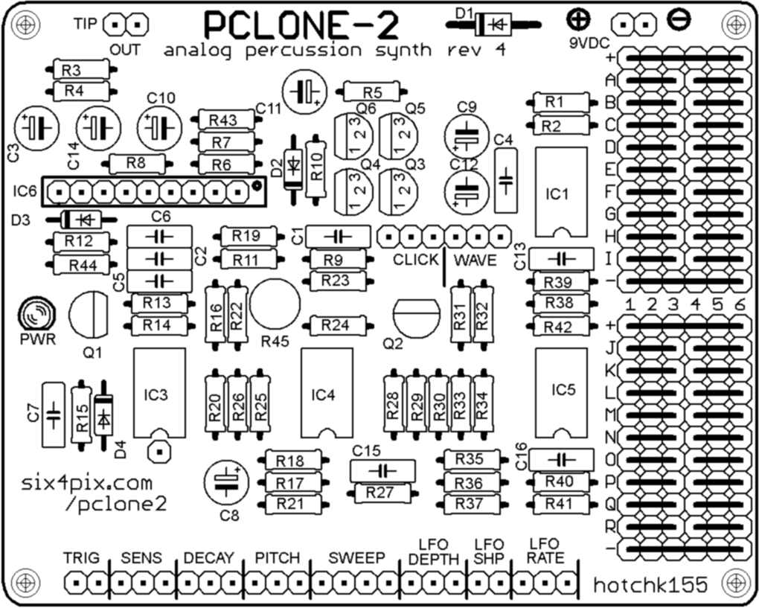

OK, Let’s begin by soldering the resistors. The different resistors can be identified by their coloured stripes, which are listed in the table below (when reading the resistor codes you can ignore the silver or gold “tolerance band”)

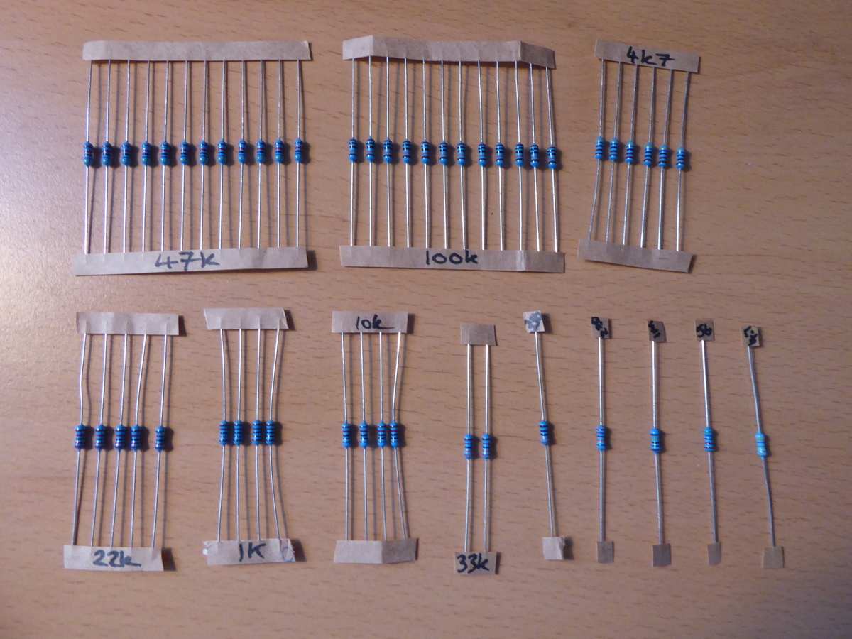

The body of the resistor may be a tan or blue colour depending on the type (carbon or metal film). The body colour doesn’t matter, so don’t worry if the colour does not match the photo.

|  |  |  |  |
| --- | --- | --- | --- |
| **Designators on PCB** | **Value** | **3 stripe colour code Followed by GOLD band for 5% carbon resistor (Tan body)** | **4 stripe colour code Followed by BROWN band for 1% metal film resistor (Blue Body)** |
| R37 | 330 | Orange-Orange-Brown | Orange-Orange-Black-Black |
| R6, R7, R17, R21 | 1k | Brown-Black-Red | Brown-Black-Black-Brown |
| R14, R20, R22, R44 | 4k7 | Yellow-Violet-Red | Yellow-Violet-Black-Brown |
| R15 | 10k | Brown-Black-Orange | Brown-Black-Black-Red |
| R13, R26, R27, R39, R43 | 22k | Red-Red-Orange | Red-Red-Black-Red |
| R8, R19 | 33k | Orange-Orange-Orange | Orange-Orange-Black-Red |
| R1, R2, R4, R5, R23, R28, R29, R33, R34, R38, R41, R42 | 47k | Yellow-Violet-Orange | Yellow-Violet-Black-Red |
| R18 | 56k | Green-Blue-Orange | Green-Blue-Black-Red |
| R9, R11, R12, R24, R25, R30, R31, R35, R36, R40 | 100k | Brown-Black-Yellow | Brown-Black-Black-Orange |
| R32 | 220k | Red-Red-Yellow | Red-Red- Black-Orange |
| R10 | 1M | Brown-Black-Green | Brown-Black-Black-Yellow |
| R16 | 4M7 | Yellow-Violet-Green | Yellow-Violet-Black-Yellow |

Note: The space for R3 is not populated. The kit does contain spare resistors and some extras of certain useful values for mods, so don’t be confused if there seem to be too many of a particular value, and don’t throw away the leftovers!

The board should look like this:

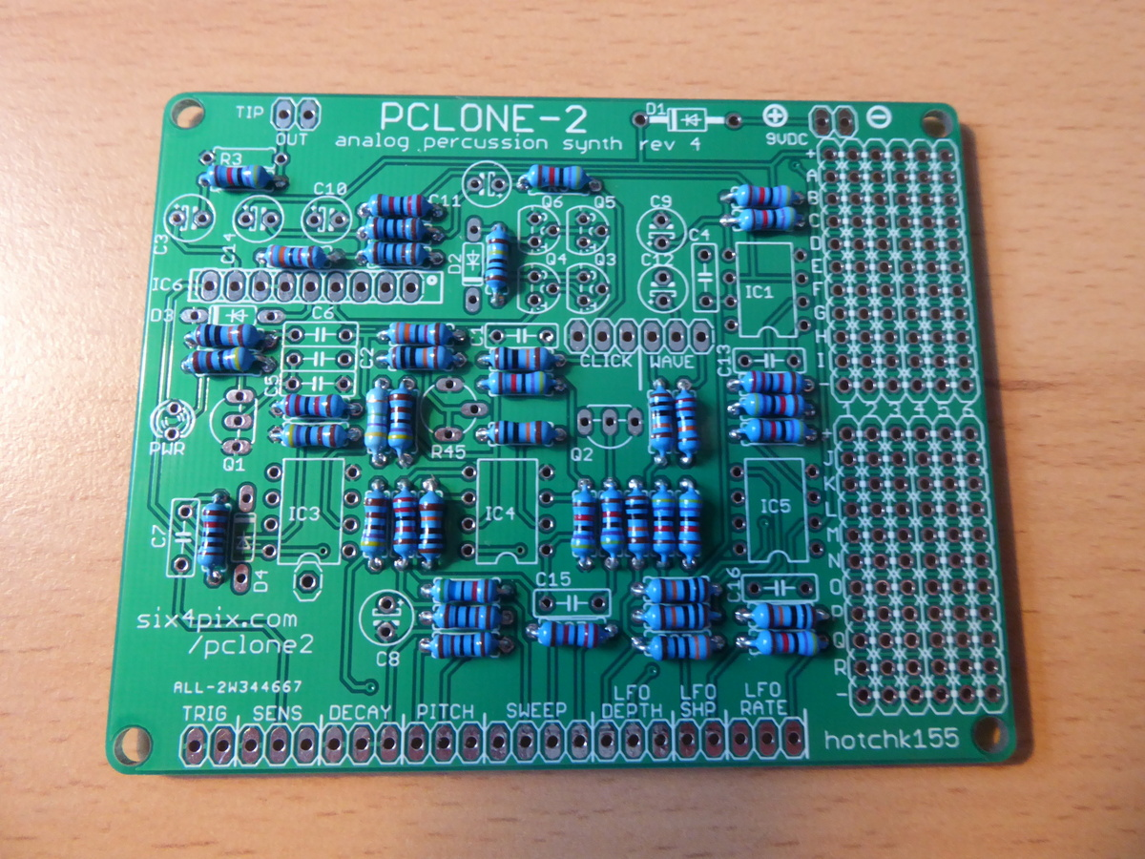

Now let’s fit the diodes, remembering that they need to be soldered the correct way around (and don’t heat them for too long when soldering)

* D2, D3 and D4 are small signal diodes with a small orange glass body with a black stripe. Make sure the black stripe lines up with the stripe marked on the circuit board symbol.
* D1 is a larger rectifier diode with a black body and silver stripe. Make sure the stripe matches up with the one printed on the board.

Your board should now look something like this

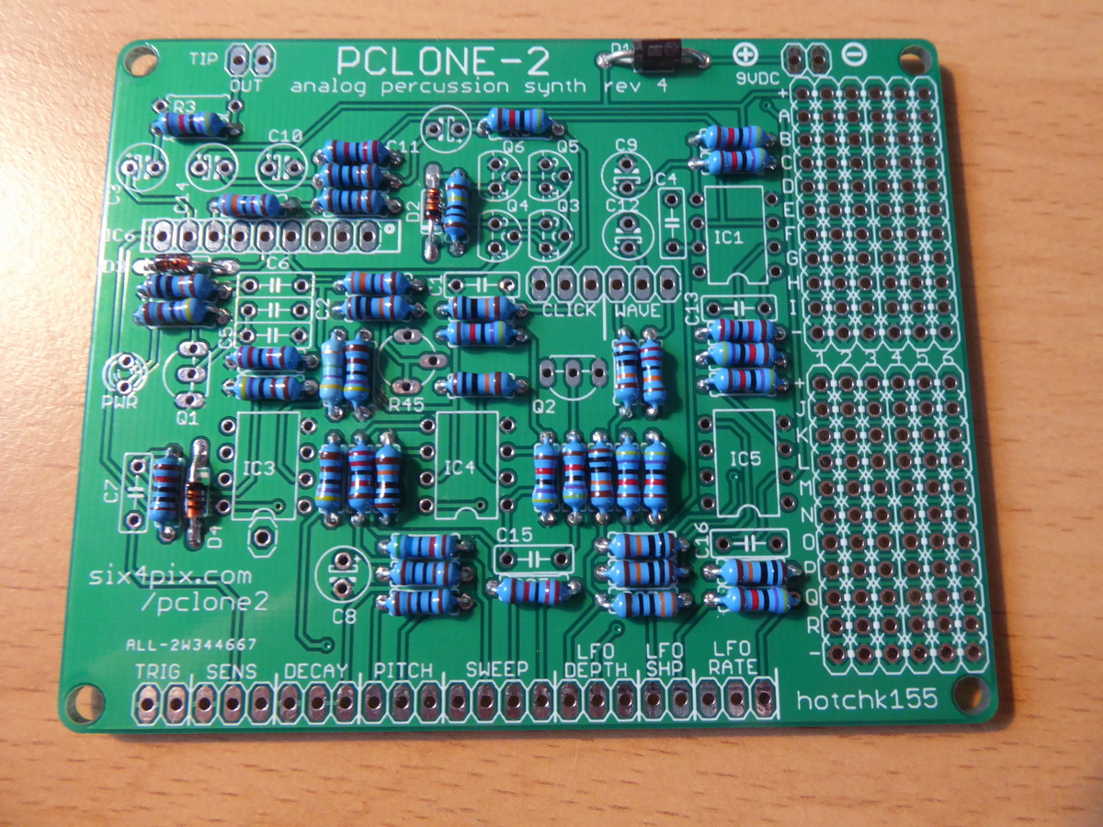

Now let’s solder the four, 8-pin IC sockets and the 9-pin header strip.

Take care to align the notch on the end of the 8 pin sockets with the marking on the board. In this layout the notch is towards the bottom of the board for each socket.

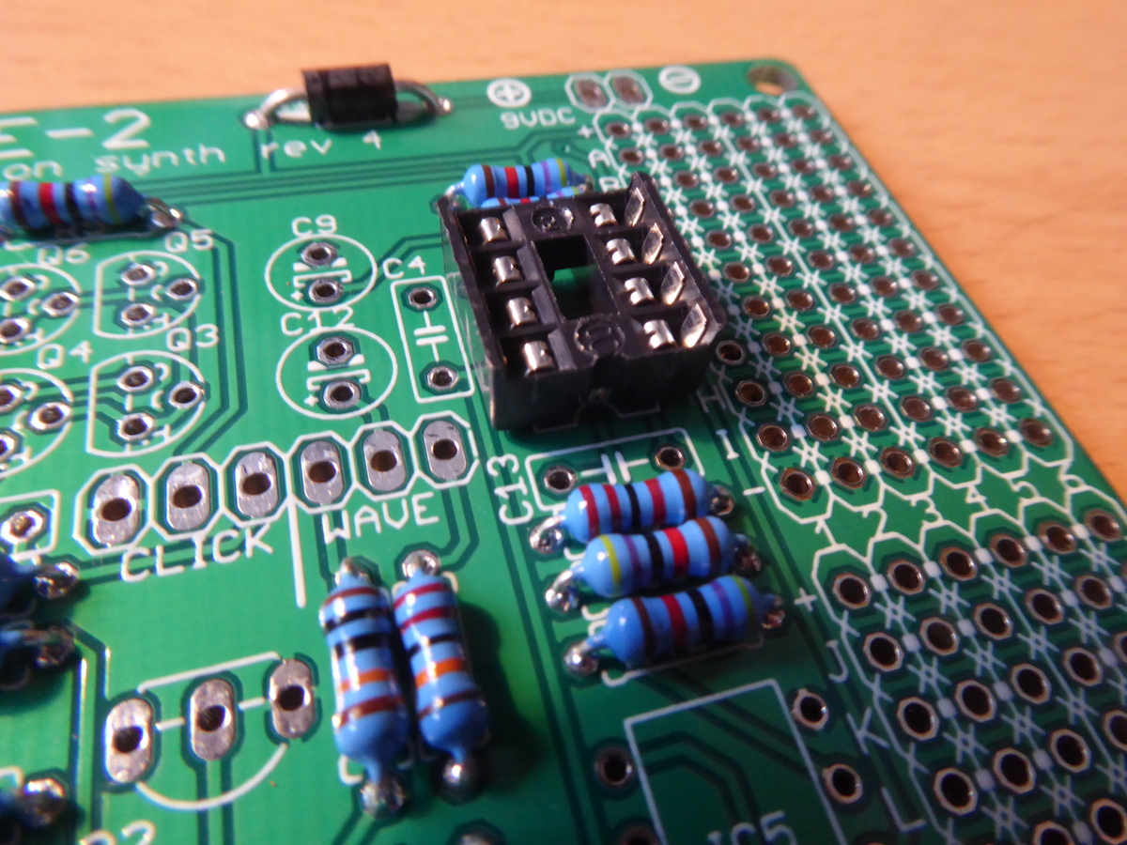

With all the sockets in place the board should be looking like this

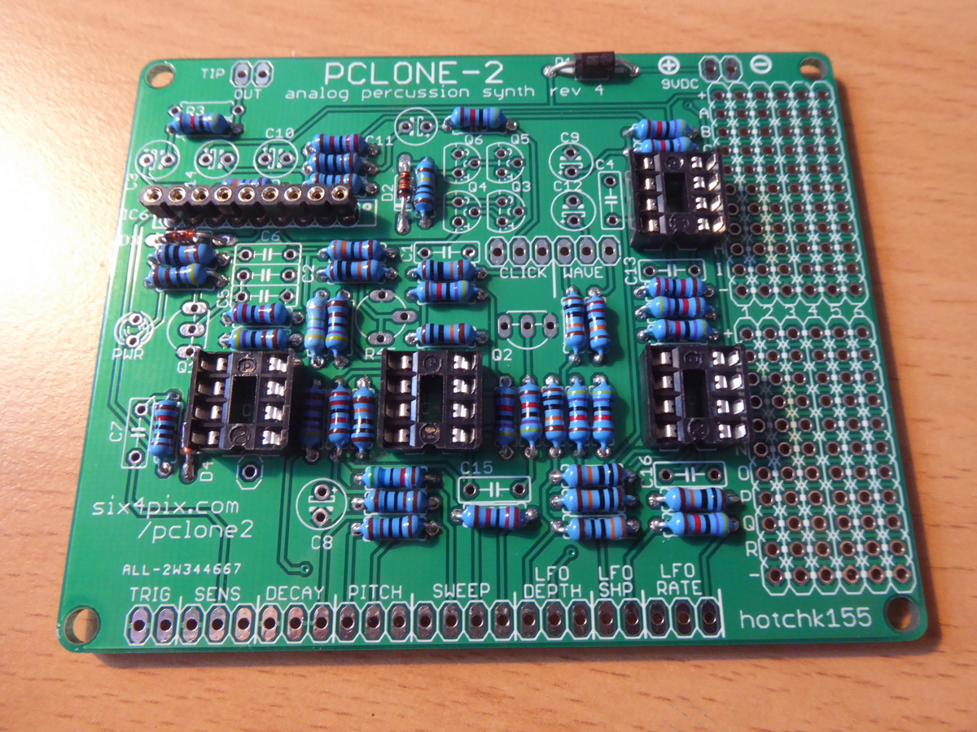

The next step is to insert the nine polyester box capacitors.

|  |  |  |
| --- | --- | --- |
| **Designators on PCB** | **Value** | **Markings** |
| C1, C2, C6 | 47nF | “47n” |
| C13 | 22nF | “22n” |
| C16 | 3.3nF | “3n3” |
| C4, C5, C7, C15 | 1nF | “1n” |

The markings will contain other codes (e.g. “47nK100”), but check they start with the indicated value (e.g. “47n”)

With these caps fitted, the board now looks like this

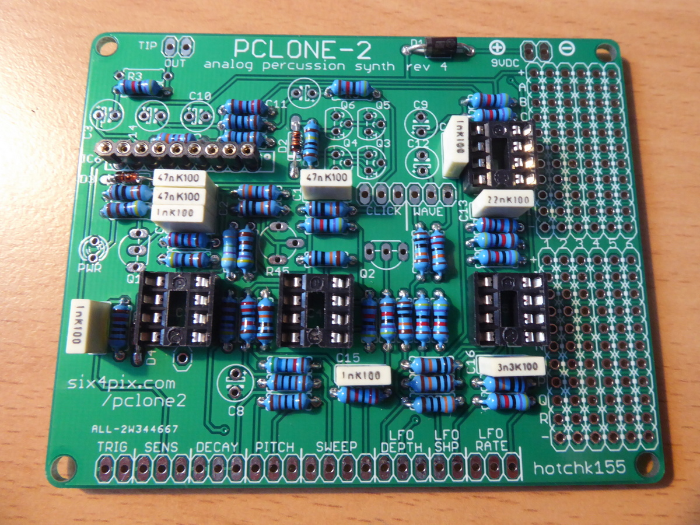

Now insert the trimmer potentiometer, R45. This is pretty tight to insert into the PCB and may need a bit of waggling – be careful not to damage the legs.

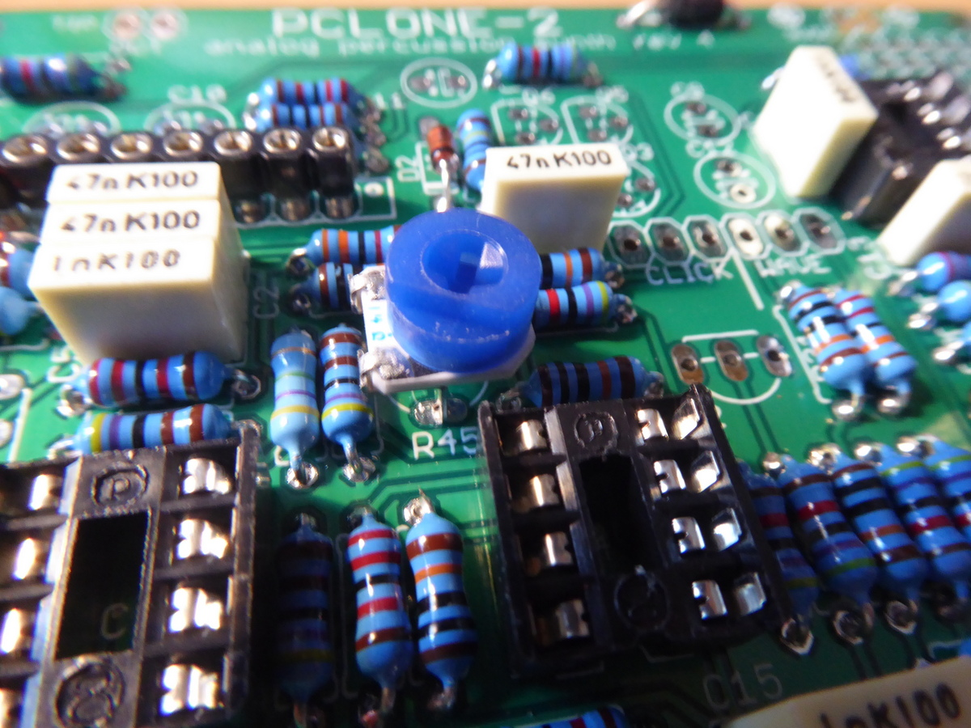

Solder the LED. It is important that this goes the right way around; you’ll see that the marking on the board shows a “flat” side next to one of the legs (beside the “PWR” label). The LED has a matching “flat” (marking the negative terminal, which also has a shorter leg). Line the flats up when inserting the LED and don’t heat for too long when soldering.

Now for transistors. There are three types of transistor in the kit

|  |  |  |
| --- | --- | --- |
| **Designators on PCB** | **Type** | **Notes** |
| Q1, Q2 | 2SC945P | NPN (Marked “945P” or “C945”) |
| Q3, Q4 | 2N3906 | PNP |
| Q5, Q6 | 2N3904 | NPN |

It is very important not to mix them up (or you might let the magic smoke out of them as soon as you apply power!). There is an extra 2N3904 in the kit – hang on to it to use for mods…

When you solder them, make sure the “D” shape of the case lines up with the D shaped marking on the board – you need to bend or splay the legs a little to get them into the holes on the board. When soldered, the transistors should sit above the board by a few millimetres.

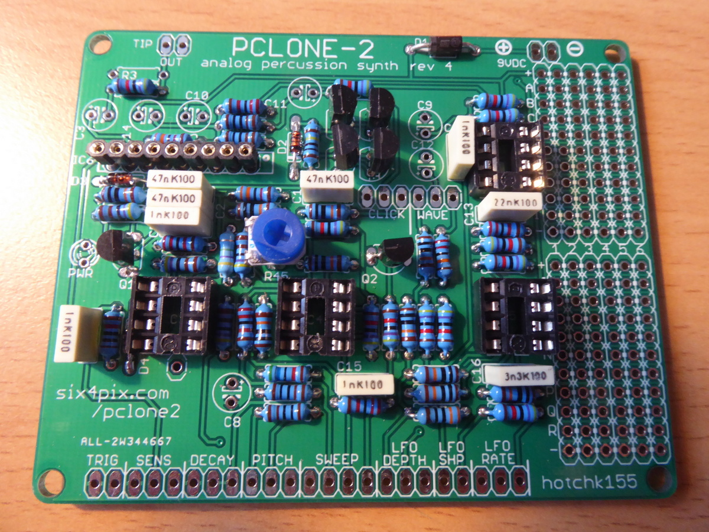

Now add the electrolytic capacitors. These need to go in the right way around. The symbols on the circuit board show a tiny little (+) sign next to one hole. Put the **longer** leg of the capacitor through the hole. The capacitor body will also have a white stripe to mark the negative terminal (aligned with the shorter leg)

As with the box capacitors they are easy to mix up, so pay special attention to the markings

|  |  |
| --- | --- |
| C3, C11, C12 | 1uF/50V |
| C8 | 2.2uF/50V |
| C9 | 10uF/16V |
| C10, C14 | 100uF/16V |

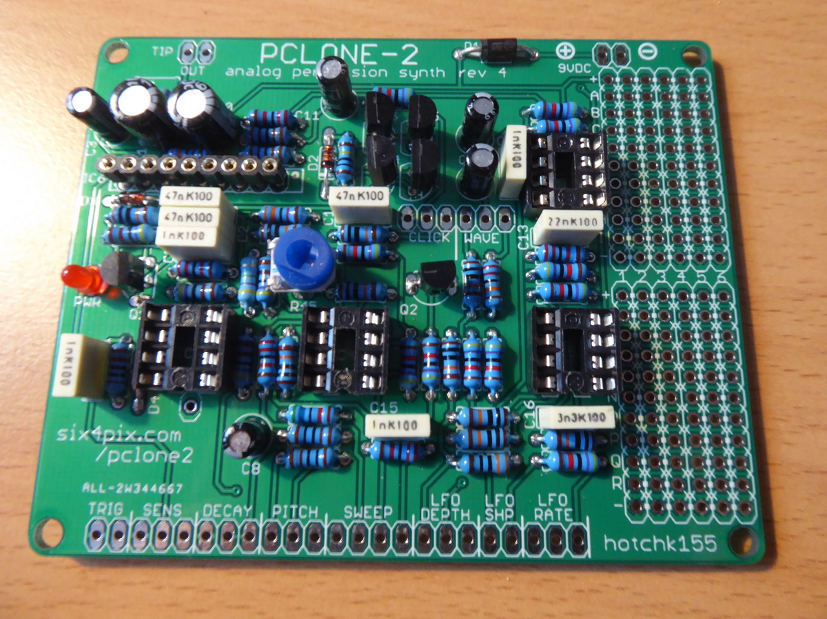

Make sure you trim back the excess component legs on the underside of the board, since the back of the board will be mounted close to the metal bodies of the potentiometers.

The rear of the board should look a bit like this

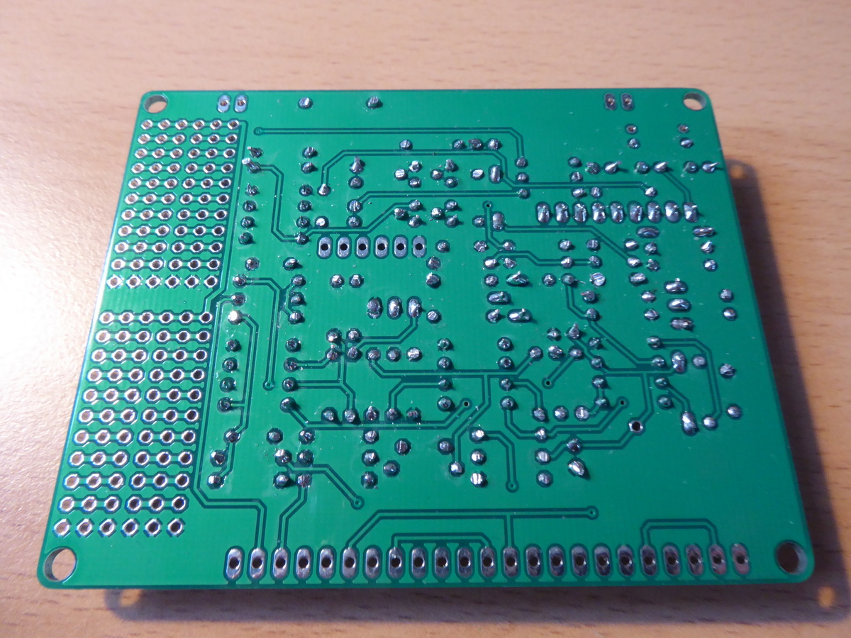

Almost there! The next step is to add the sockets that will join the main PCB to the control panel PCB.

Start by inserting the longer 23-pin header through its holes. Note that **the headers are** **attached to the underside of the PCB** as shown in the photo.

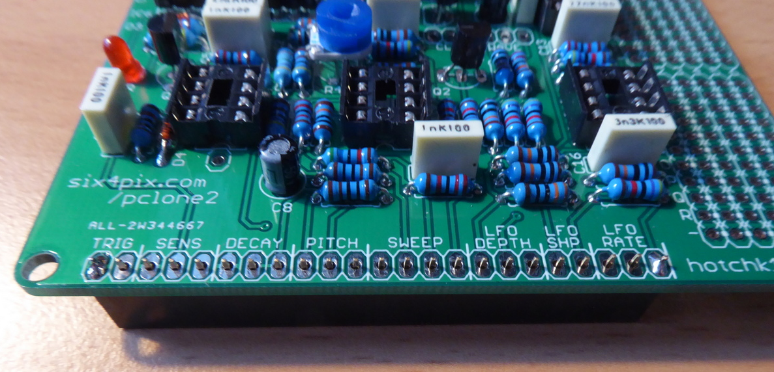

It can help to stand the board on the header while soldering (support the other edge of the board so that the header is perpendicular to the board.

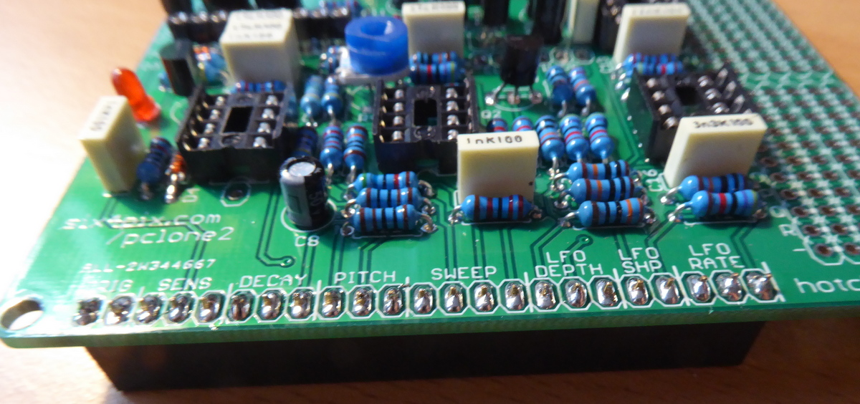

Repeat this process for the 6-pin female header, being careful not to damage the nearby components with the soldering iron!

Now let’s insert the ICs.

|  |  |  |
| --- | --- | --- |
| IC1 | RC4558 | Op-amp DIP8 |
| IC3, IC4, IC5 | LM2904 | Op-amp DIP8 |
| IC6 | BA6110 | Op amp SIL9 – 9 pins in a single row |

For IC1, IC3, IC4, IC5, make sure that the notch or dimple on the body of the chip matches the notch shown in the symbol on the board (which should also match the notch on the socket). The location for each notch is toward the bottom edge of the board.

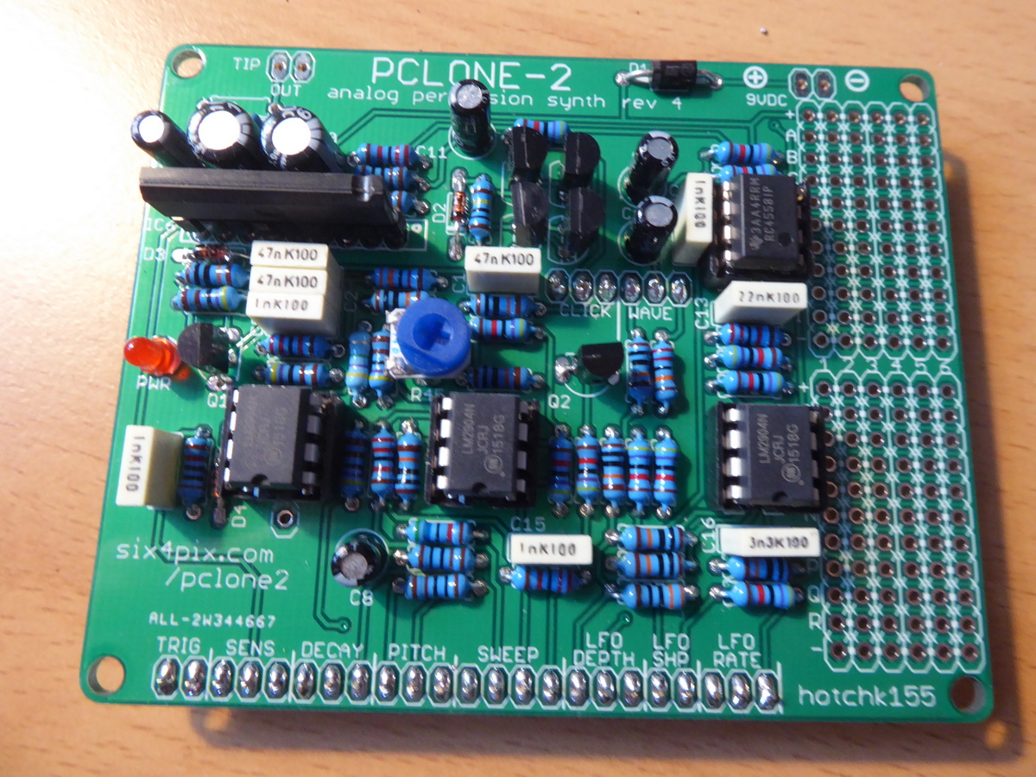

For IC6, there is a notch along the top of the chip. This should be towards the right (There is a dot marked on the board).

A firm push is needed to insert IC6 but take special care not to bend of break any legs – These are old chips (no longer manufactured) and your chip may have been recovered from other equipment, so the legs can be a bit more fragile than the other ICs.

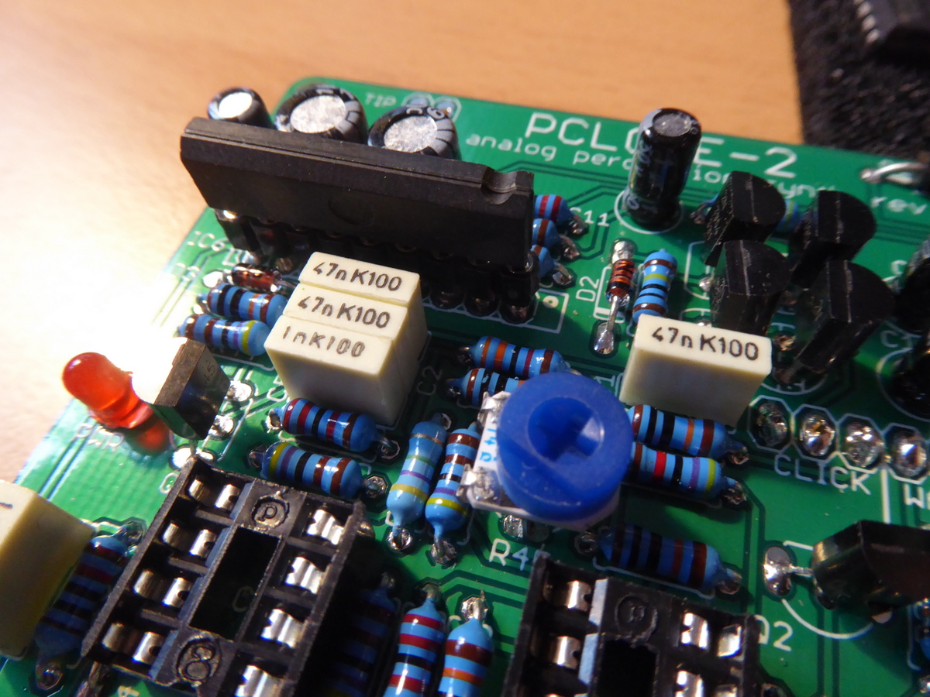

And so, on to the front panel…

Locate the front panel PCB and ensure that the pre-soldered connectors on the front panel are undamaged.

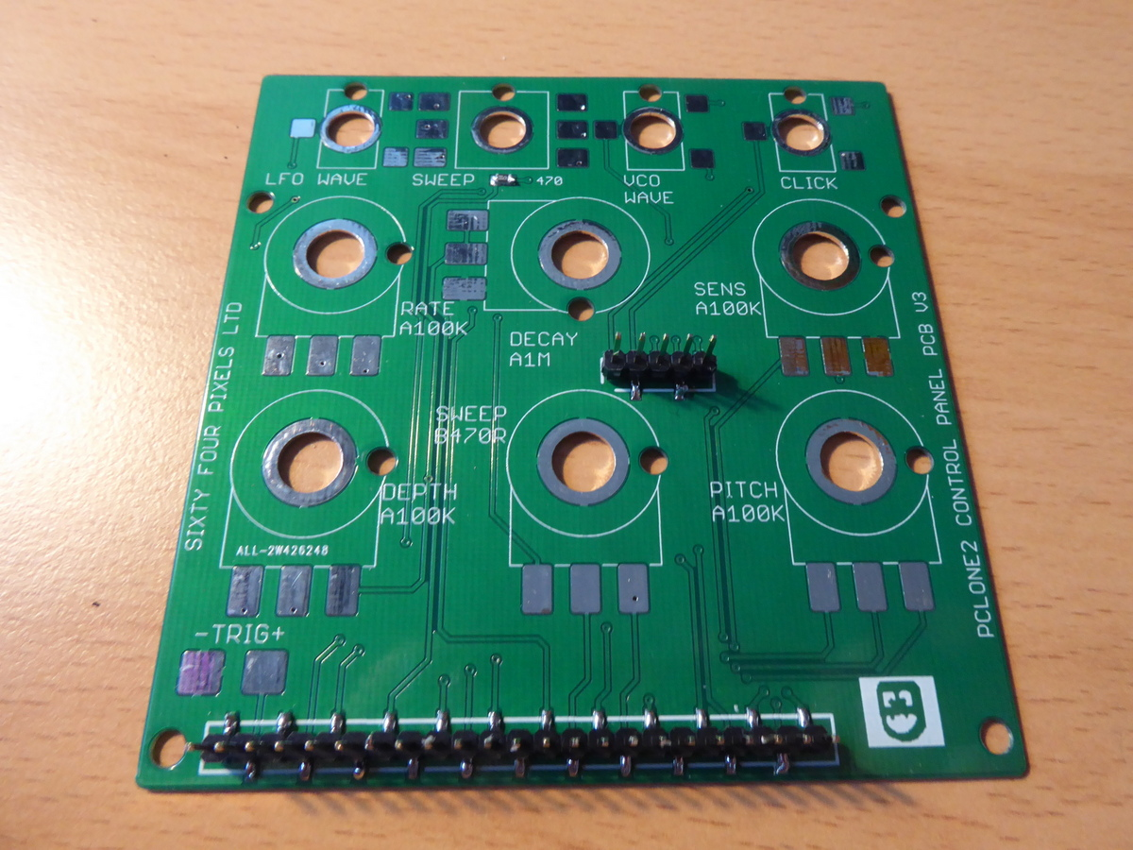

Locate the acrylic case front panel and remove all the protective film

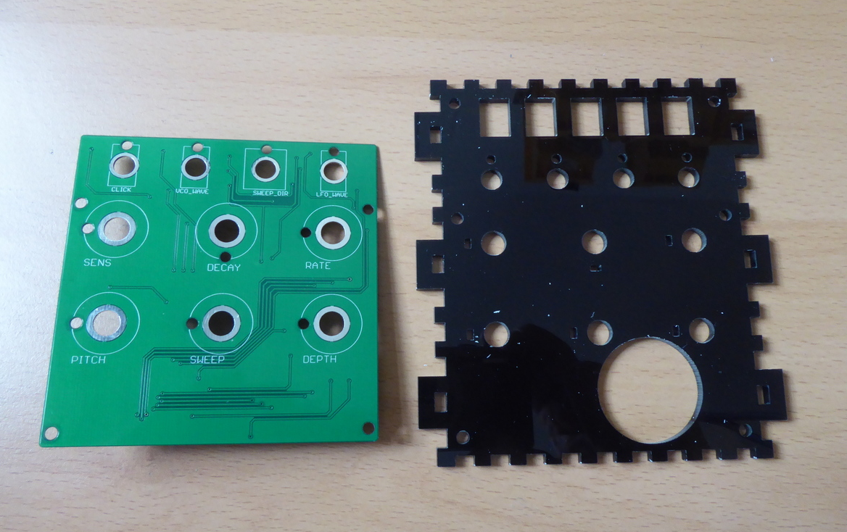

Locate the piezo disk and adhesive pads

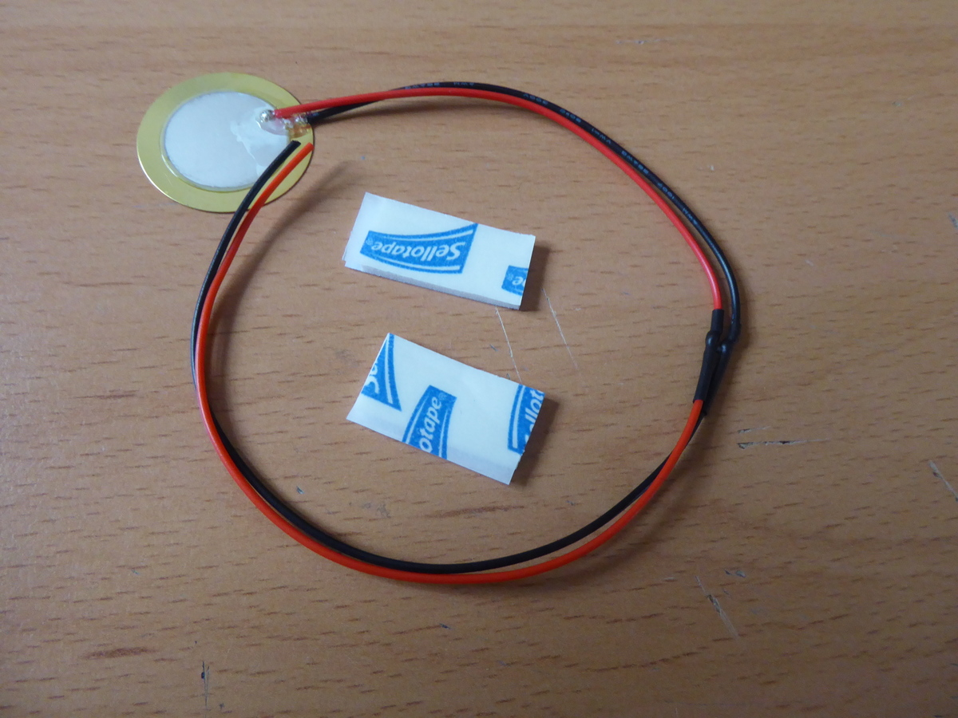

Place the front panel over the PCB so that all the holes line up and the large round cut out is on the right side (and the PCB connectors are on the opposite side)

Stick half of one of the pads to the PCB in the centre of the circular cut-out. Stack another half pad on top so the pad is double thickness.

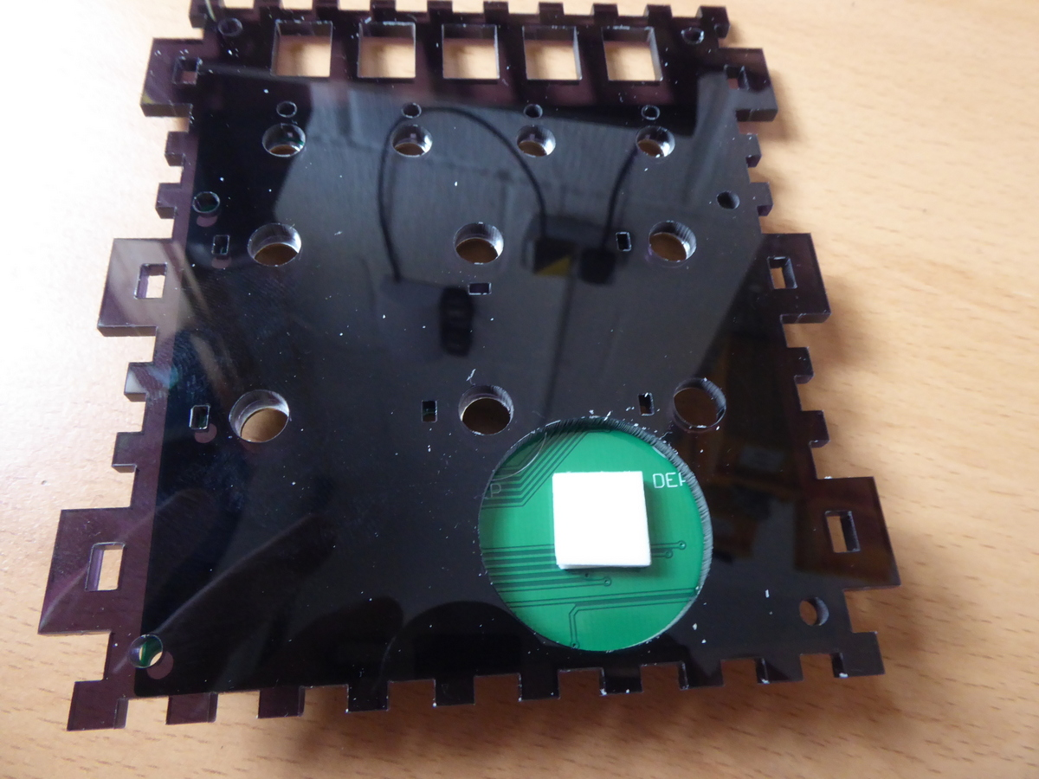

Stick the piezo disk to the pad in the centre of the cut out so that it fits inside the cut out space and **the piezo wires lead off to the left (9 o’clock position)**

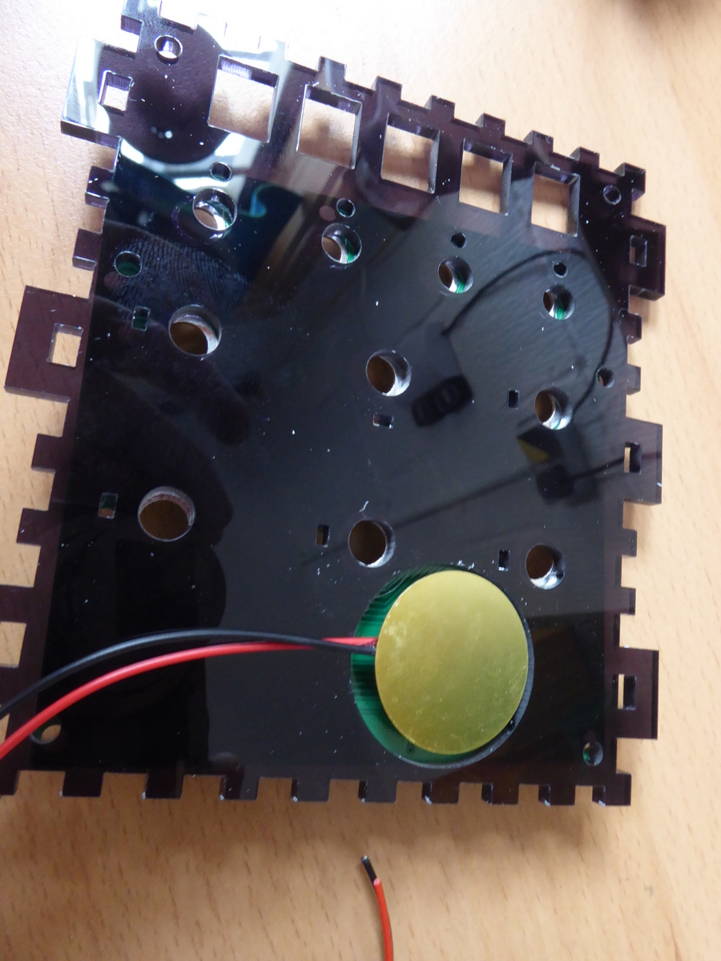

Carefully slide the acrylic panel along the wires, being sure not to break the connection to the piezo disk. The PCB should now look like this…

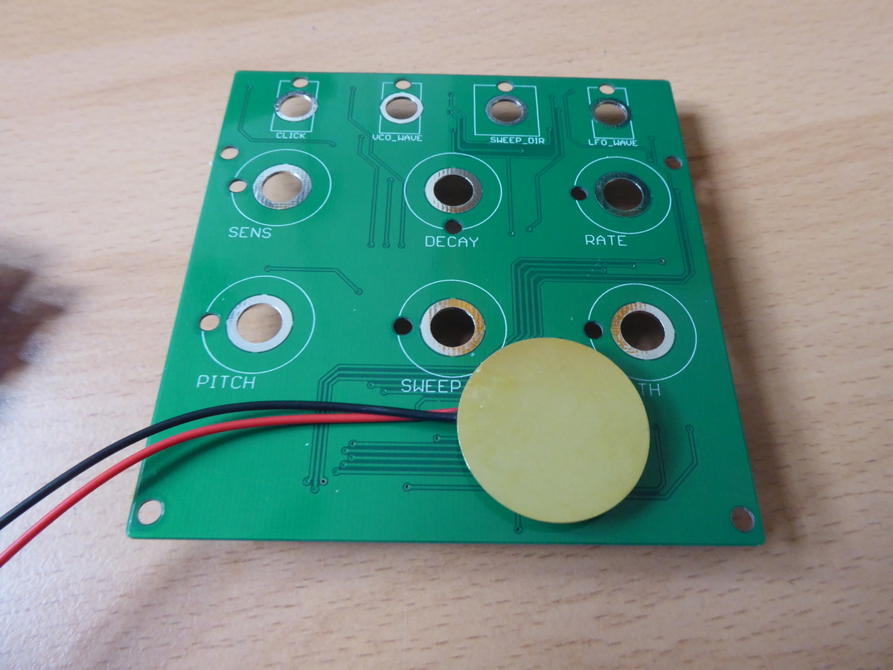

Remove all the nuts and washers from the potentiometers:

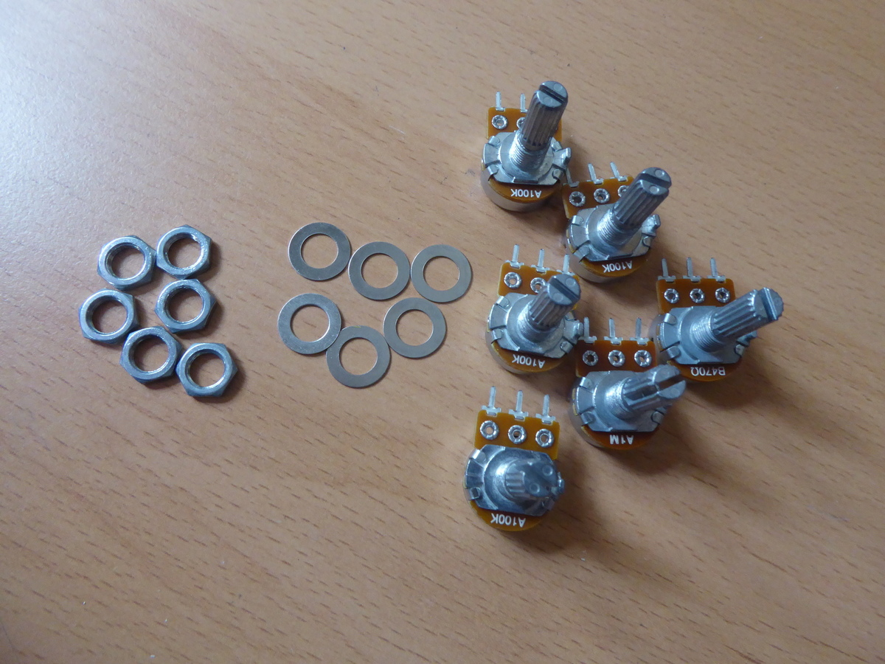

Locate the 470R potentiometer and use pliers to carefully bend the legs of the potentiometer upwards (in the same direction as the spindle) as shown below

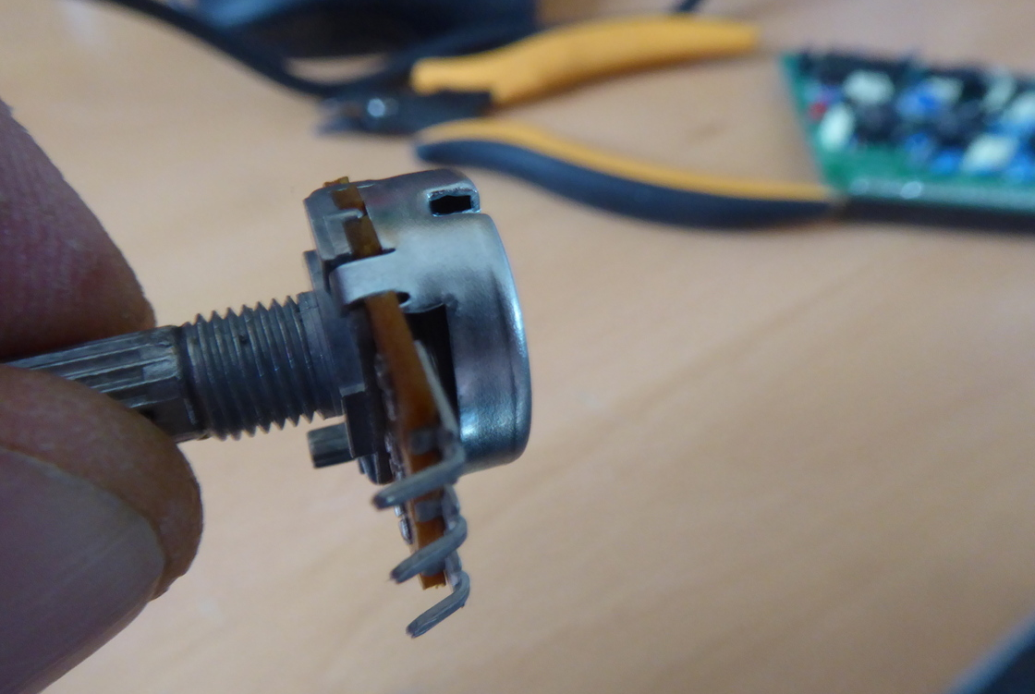

Place the 470R potentiometer through the “sweep” position and attach the washer and nut to the front side and tighten the nut

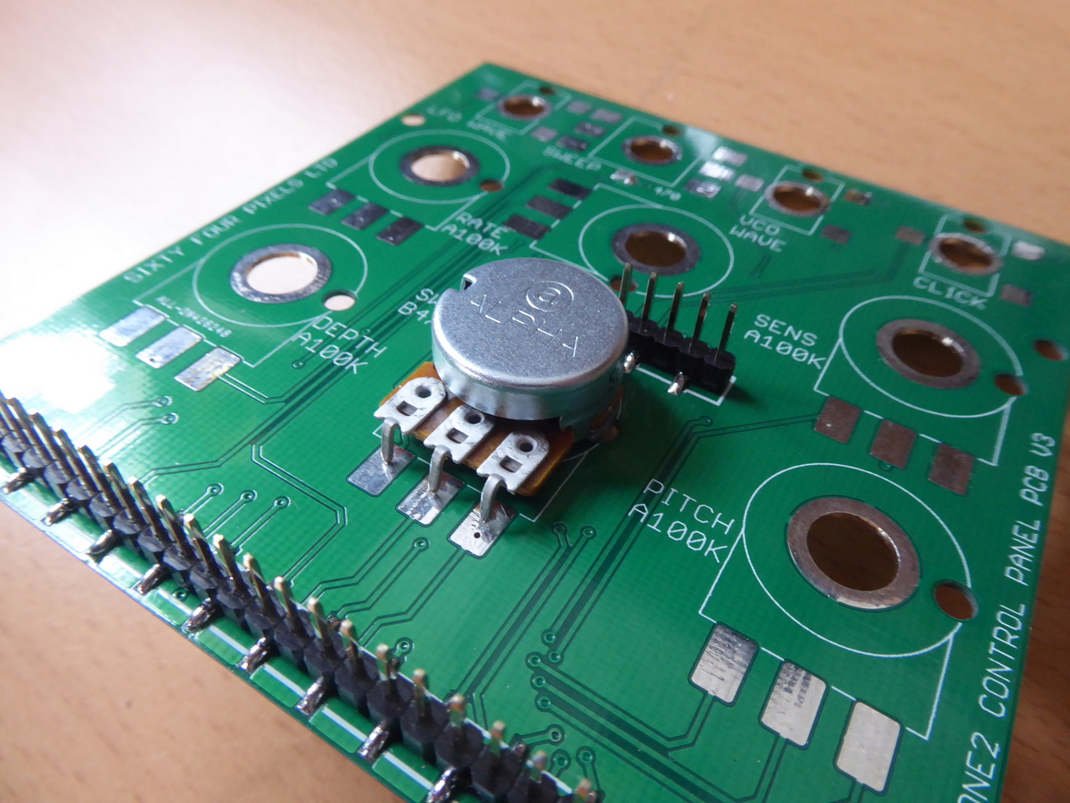

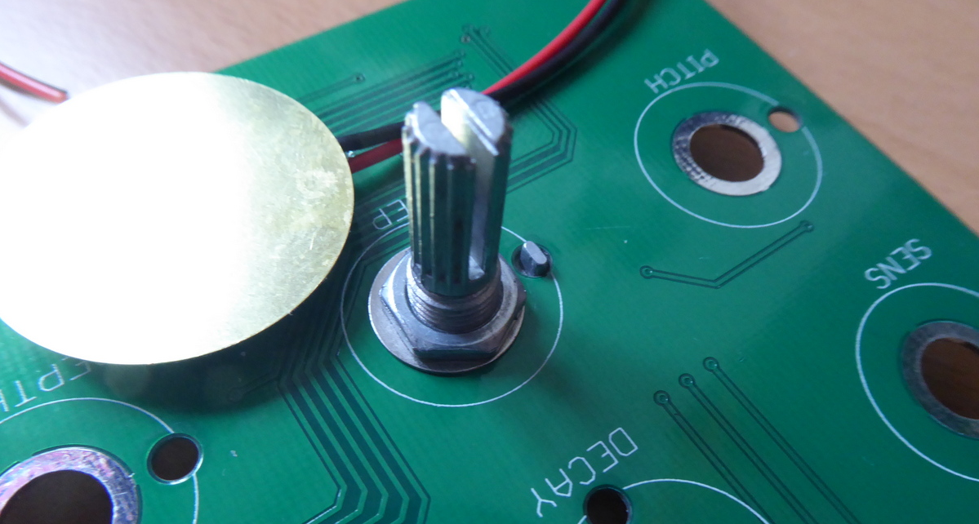

Use a generous amount of solder to attach the legs of the potentiometer to the solder pads on the PCB. A wide roll of tape makes a good support for the board during this process.

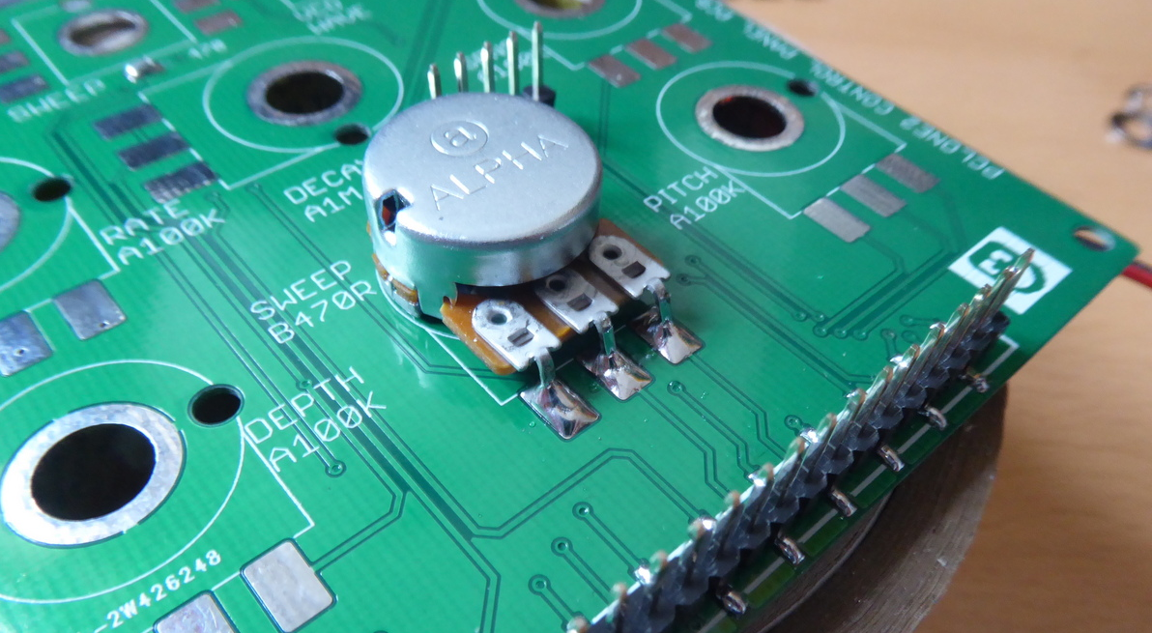

Repeat this process for all six potentiometers. I recommend you work through them in the order of the following table for best access during soldering:

|  |  |
| --- | --- |
| 470R LIN | Sweep |
| 1M LOG | Decay |
| 100K LOG | Rate |
| 100K LOG | Sensitivity |
| 100K LOG | Depth |
| 100K LOG | Pitch |

The end result should look like this

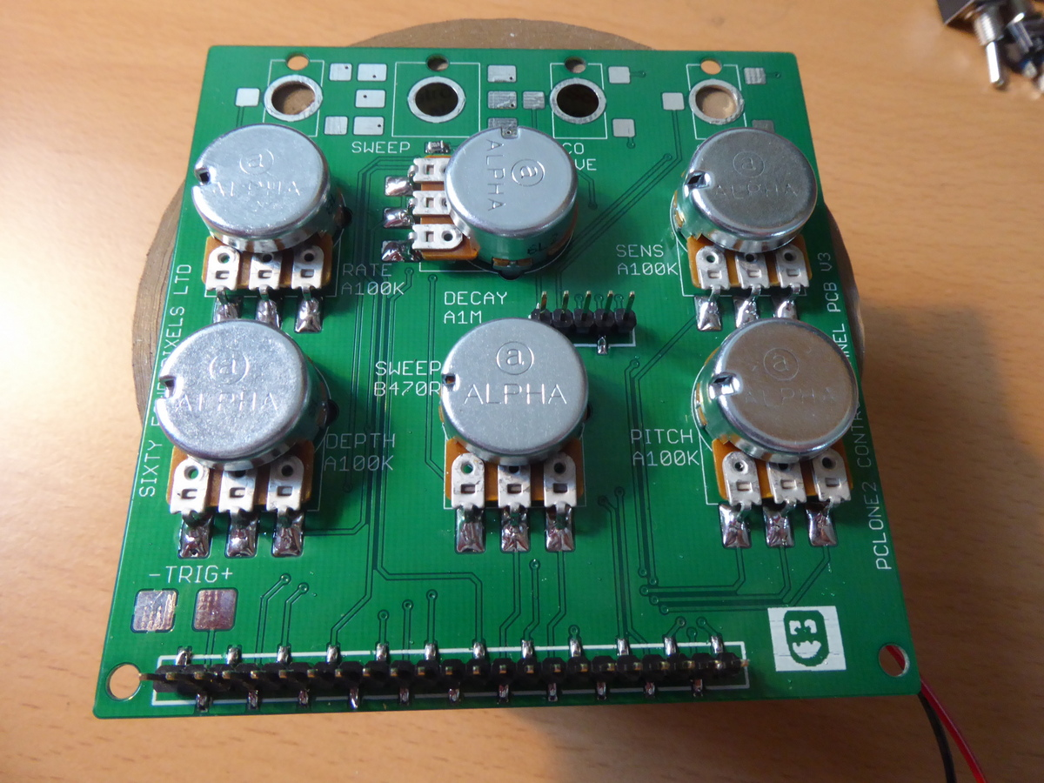

Remove all the nuts and washers from the switches

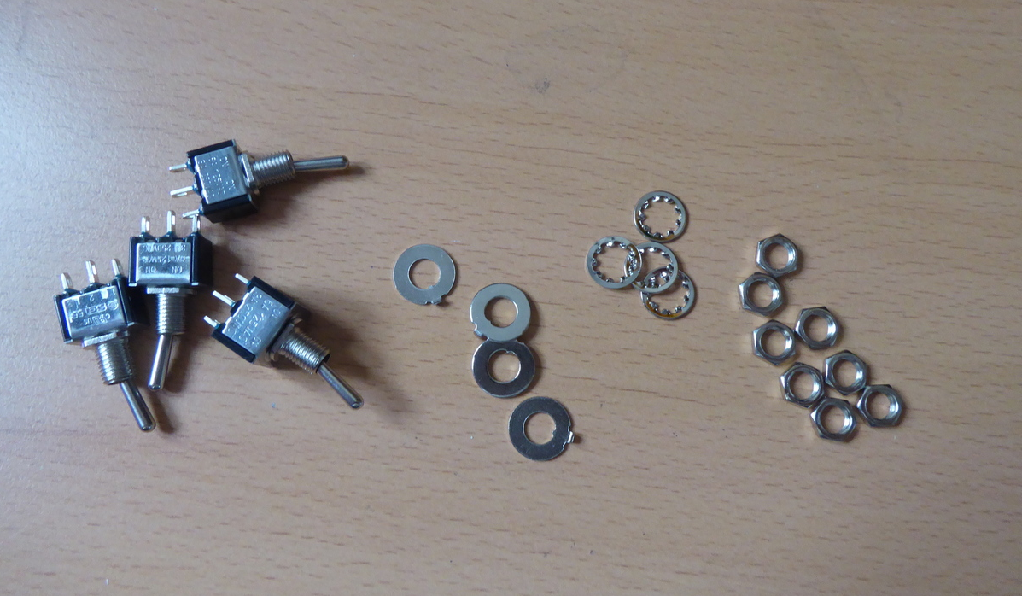

Find the six pin DPDT switch and place it in the Sweep Direction switch position. Place a tabbed washer over the front of the switch such that the tab faces backwards through the locating hole in the PCB and secure with a nut

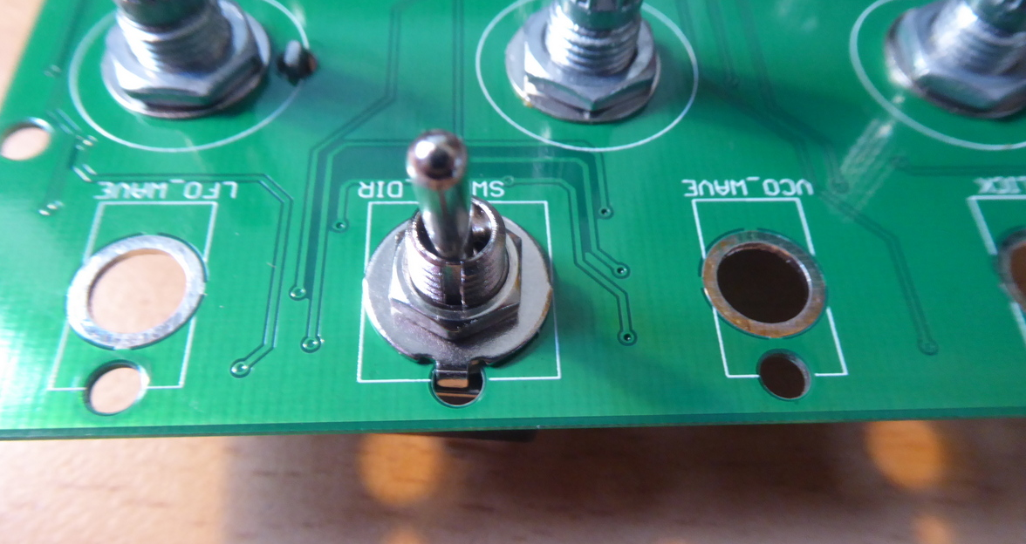

Cut a piece of the tinned copper wire (bare, silver-coloured wire that looks a bit like solder) about 5cm long and bend into a U-shape so it can be fed through the middle holes in the switch pins and solder it in place

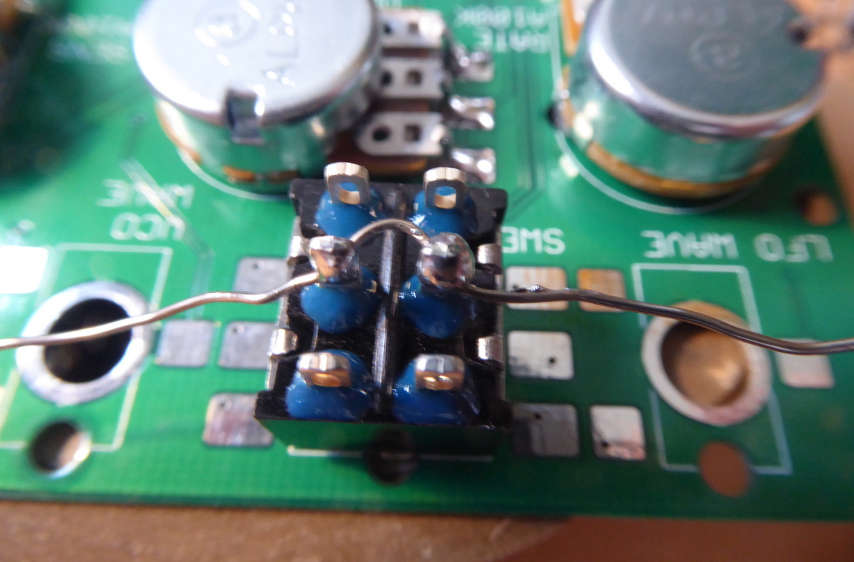

**Cut the middle section of the wire out** and repeat for the other two pairs of pins, so the you have six separate wires connected to each of the six pins.

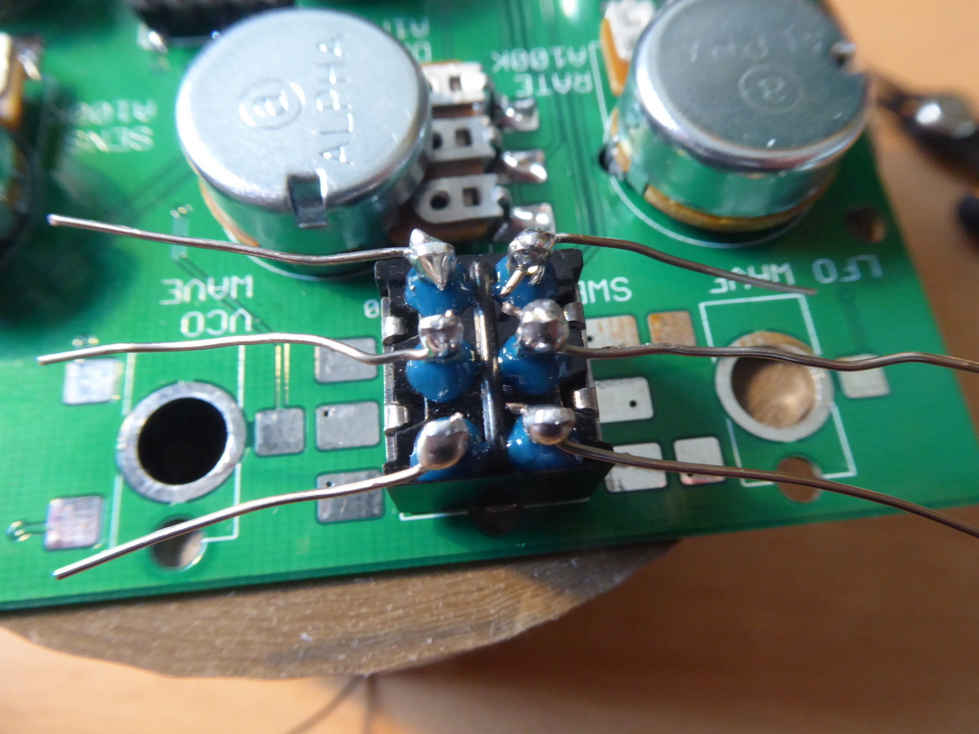

Bend the wires down to meet the pads, making sure they are not touching the body of the switch

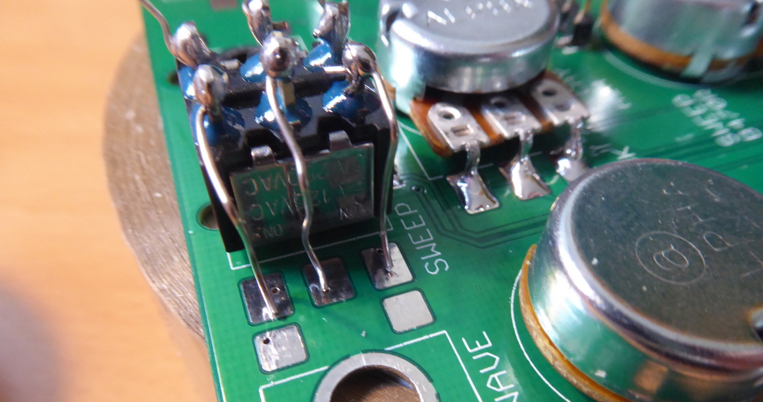

Use generous solder blobs to connect the wires to the pads

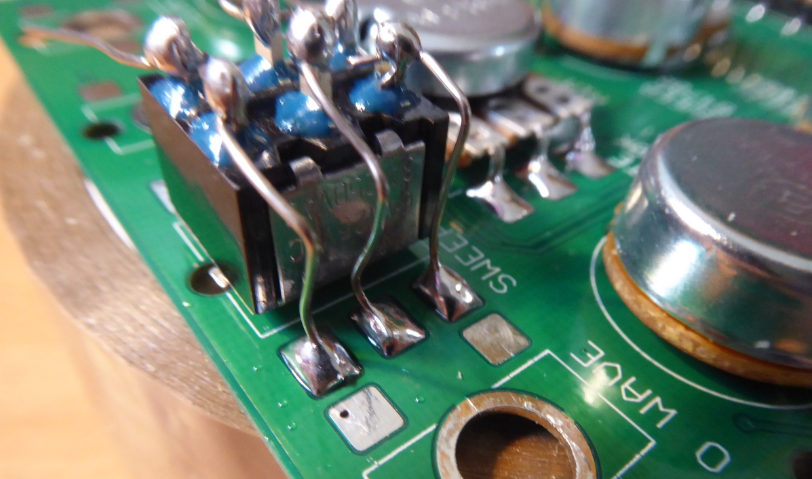

Repeat for the VCO Wave switch, using one of the remaining three SPST switches

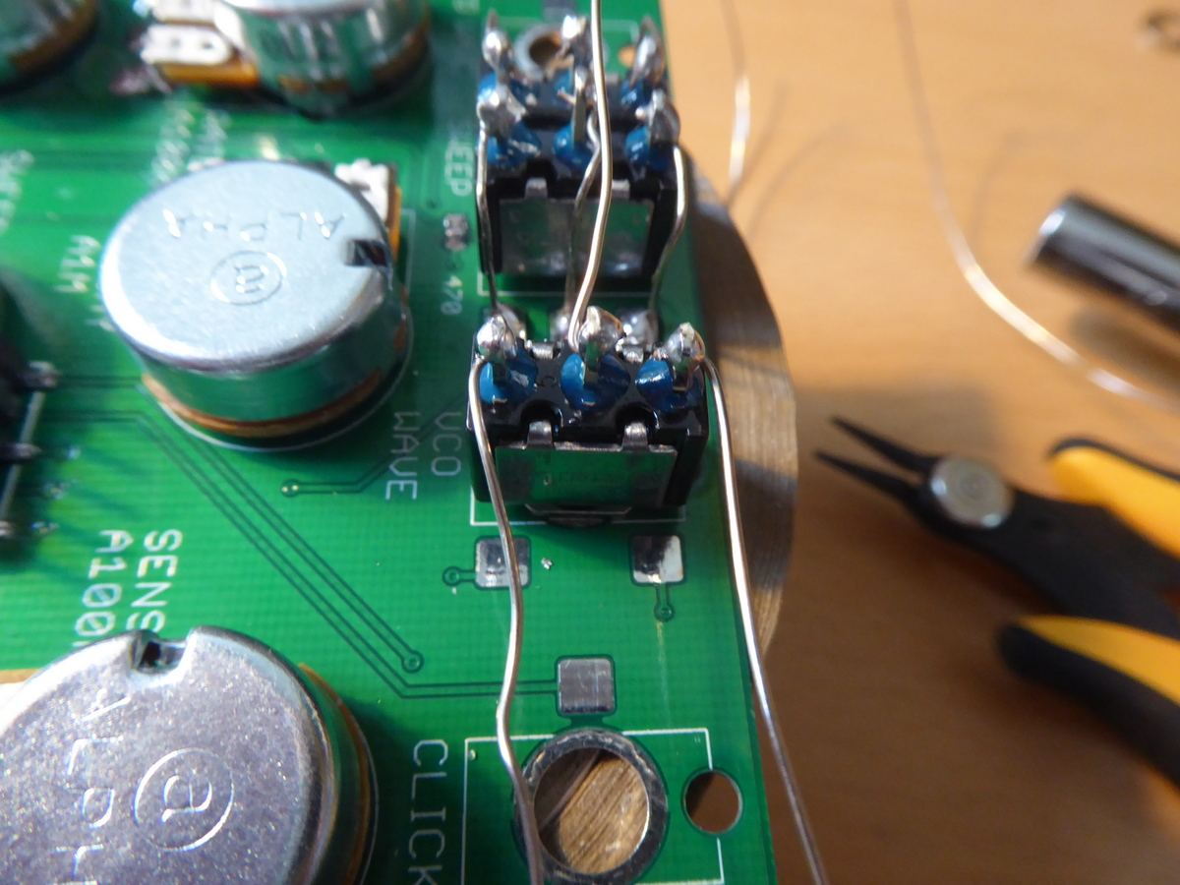

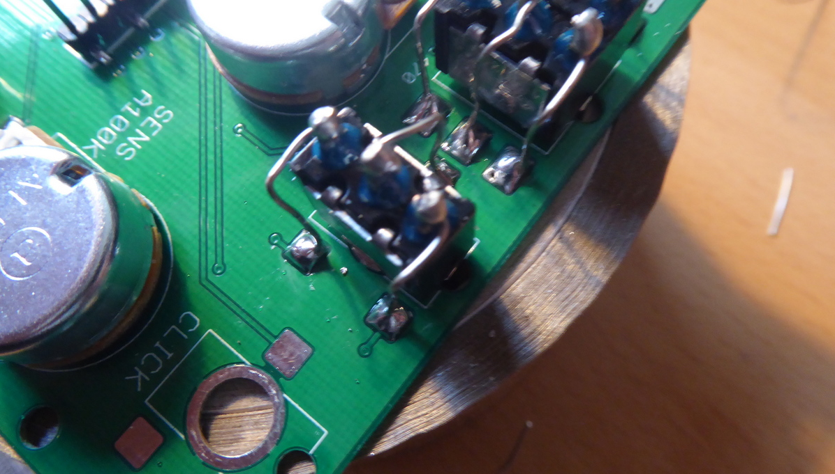

And then for LFO Wave and Click, such that all four switches are now soldered to the PCB.

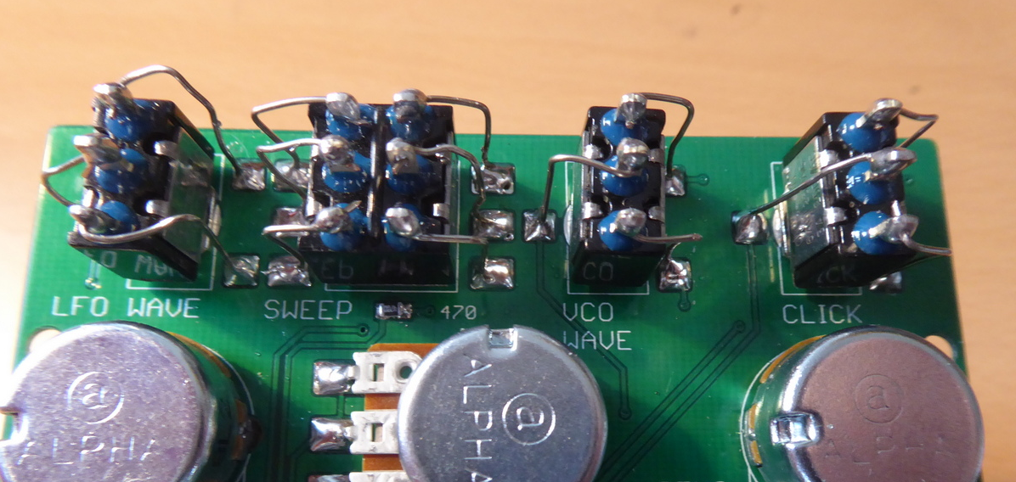

Carefully bend the piezo wires through 90 degrees making sure that they can be routed up to between the Click and VCO Wave switches **without the black and red wires crossing** (as they will need to fit into a tight space)

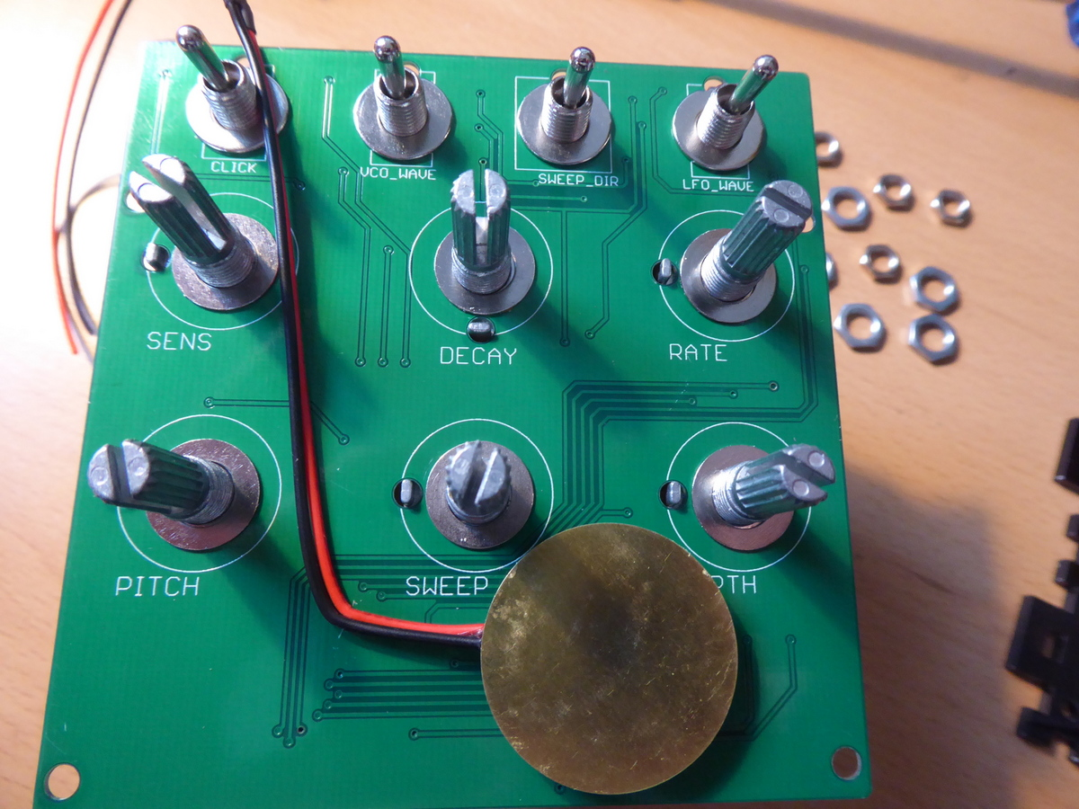

Remove all the nuts for the switches and pots but leave the washers in place. Place the acrylic panel over the PCB being careful to prevent the piezo wires from crossing over each other or getting trapped in front of one of the washers. Then replace the nuts

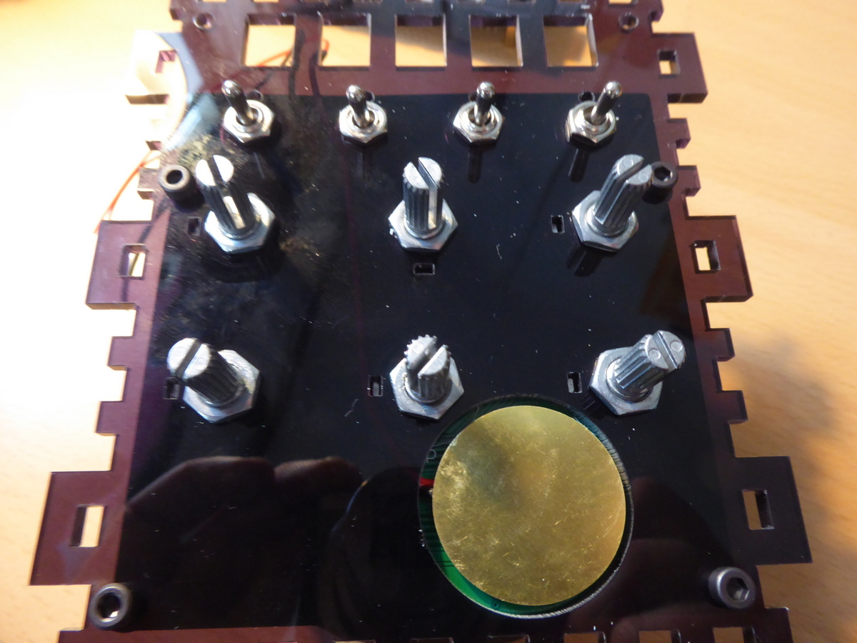

At this point locate the four M3 washers and slide them in between the PCB and front panel around the four lower holes (see position of bolts in picture above). Dropping the M3 x 12mm hex bolts (the four longer bolts) through the holes will keep the washers in place

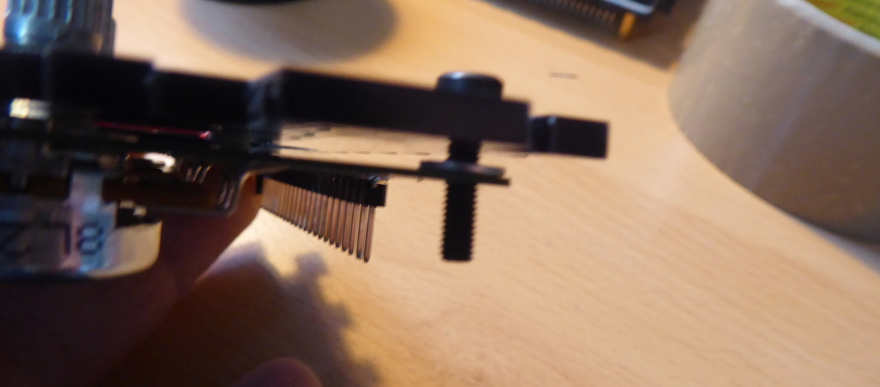

Place half of one of the adhesive pads on the face of the piezo disk but **leave the backing material on the top** **side** (so the it will not stick to the face place)

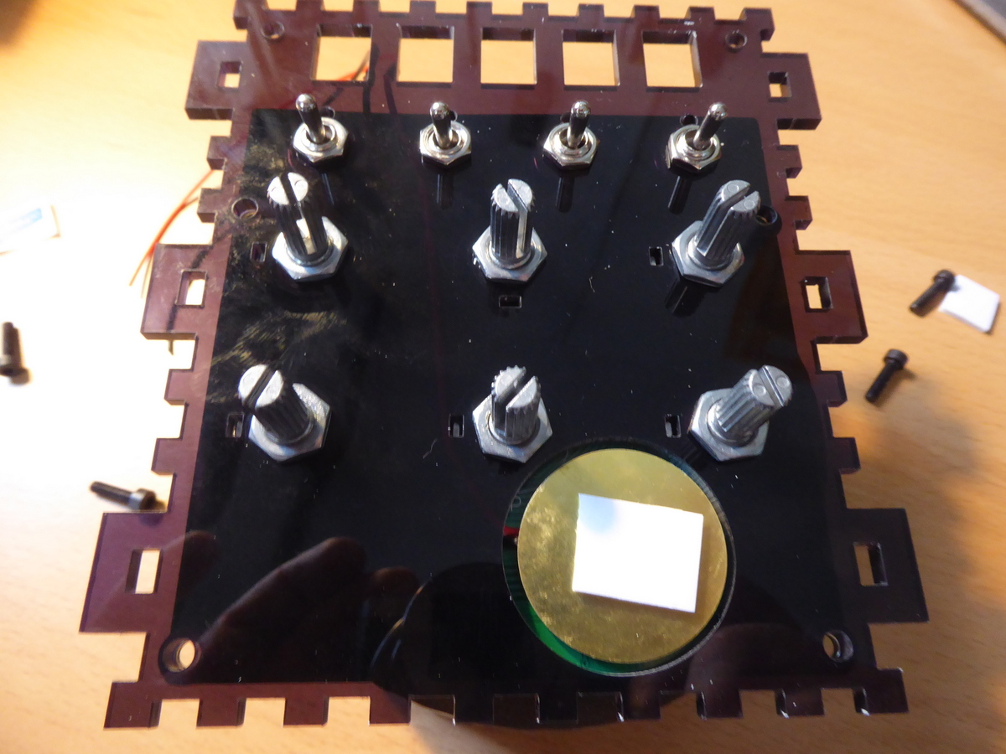

Attach the face place, using the four M3/12mm bolts and the hex standoff pillars. Use the two M3 nuts with two of the M3/8mm hex bolts to secure the top holes

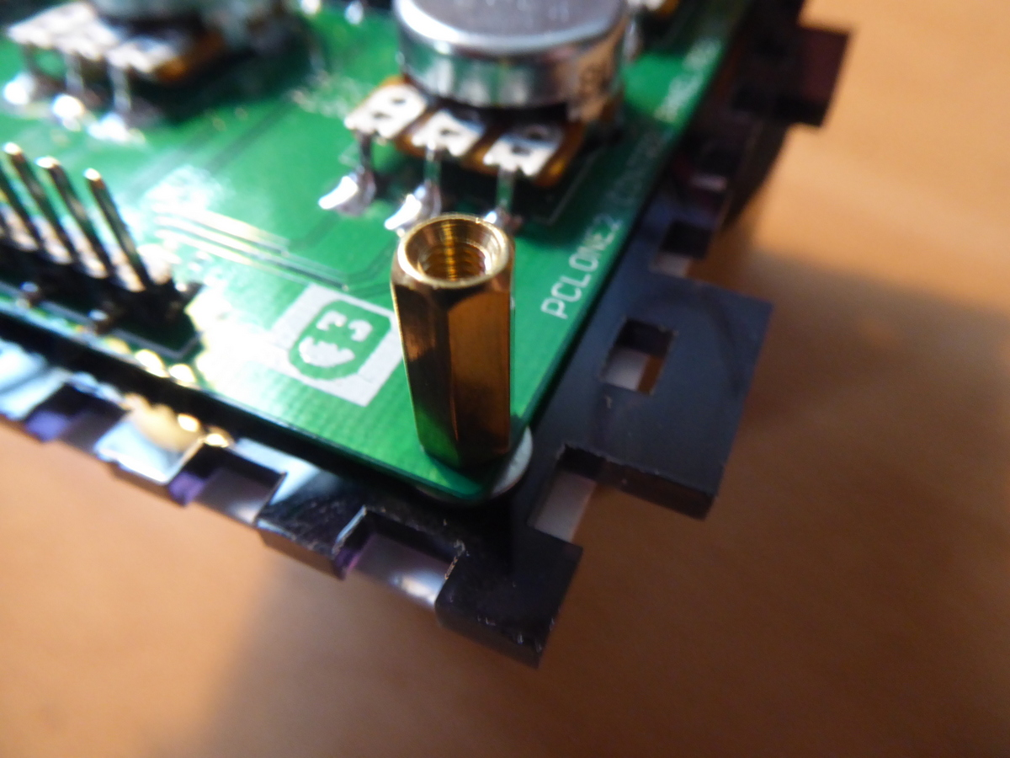

Ensure that all the nuts are fitted snugly into the holes in the face place and that the piezo wires are lying flat. The front panel is now coming into shape!

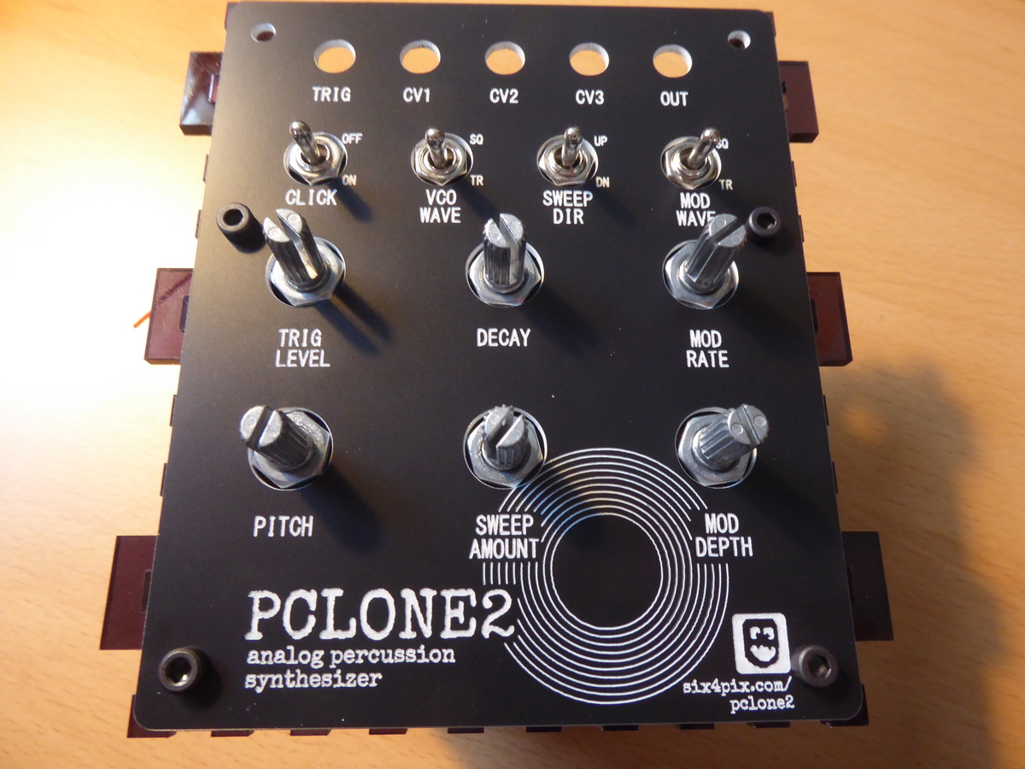

Locate the 3.5mm jack sockets and knurled nuts.

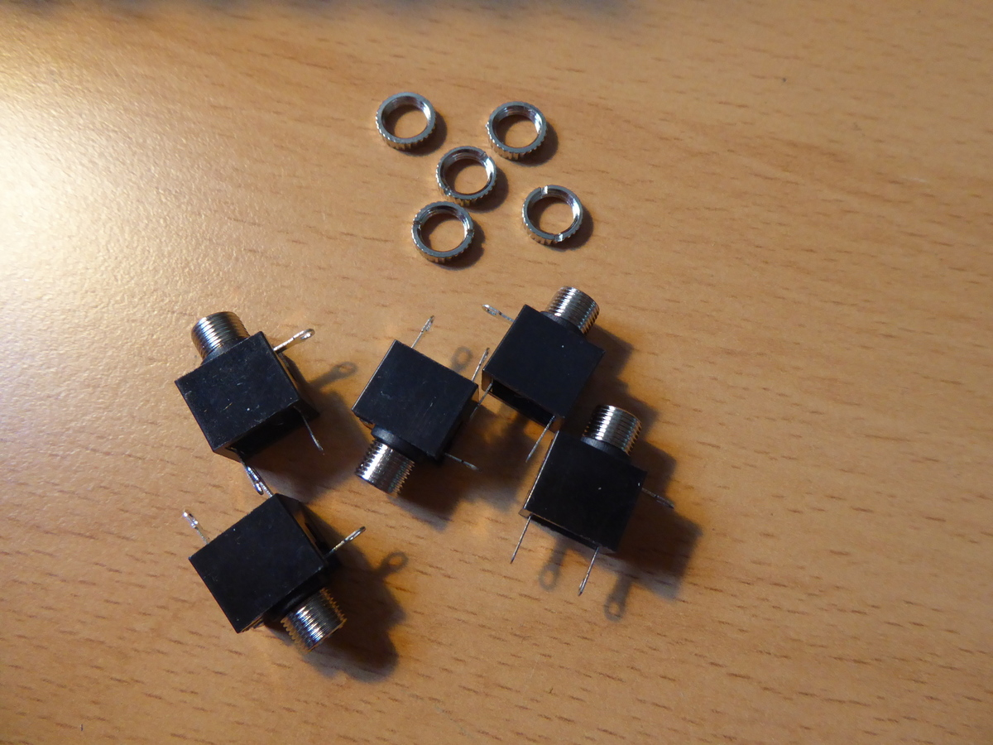

Bend the shield pin of each socket back along the body at about 45 degrees.

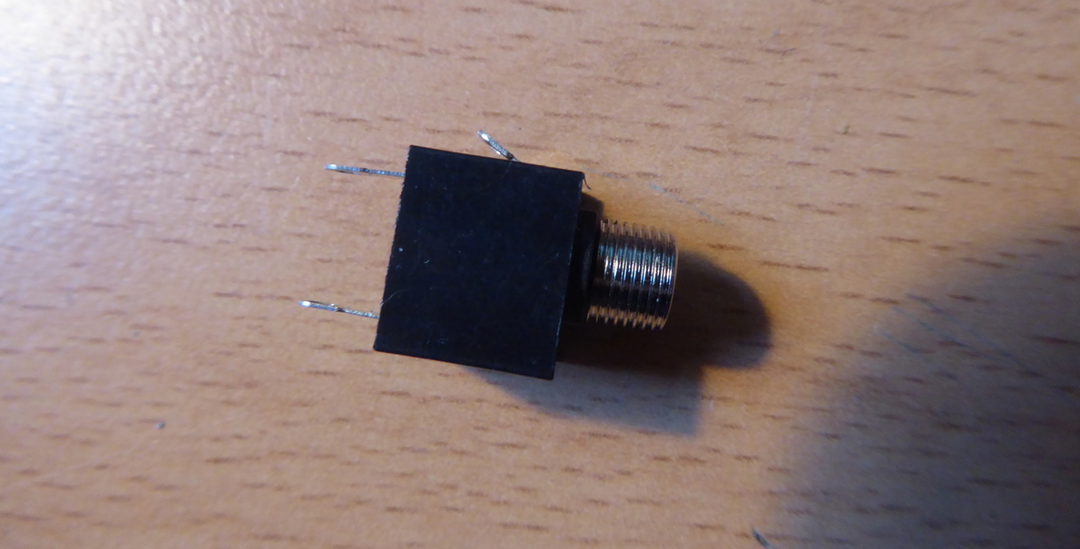

Insert all five sockets in their holes with the shield tabs facing towards the PCB

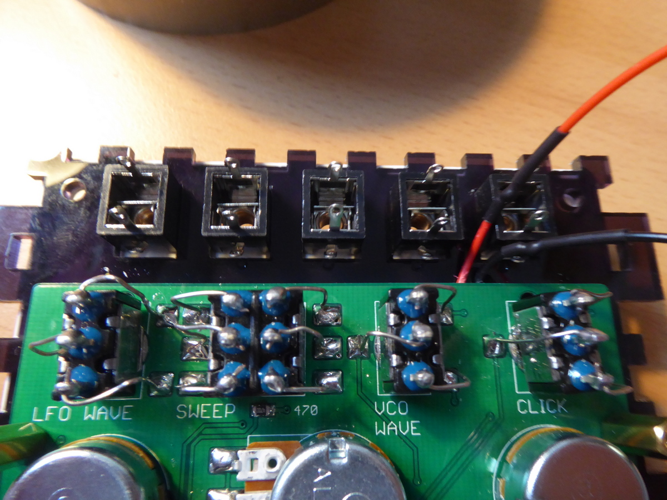

Join all the shield tabs by soldering a single piece of the bare copper wire between each of them

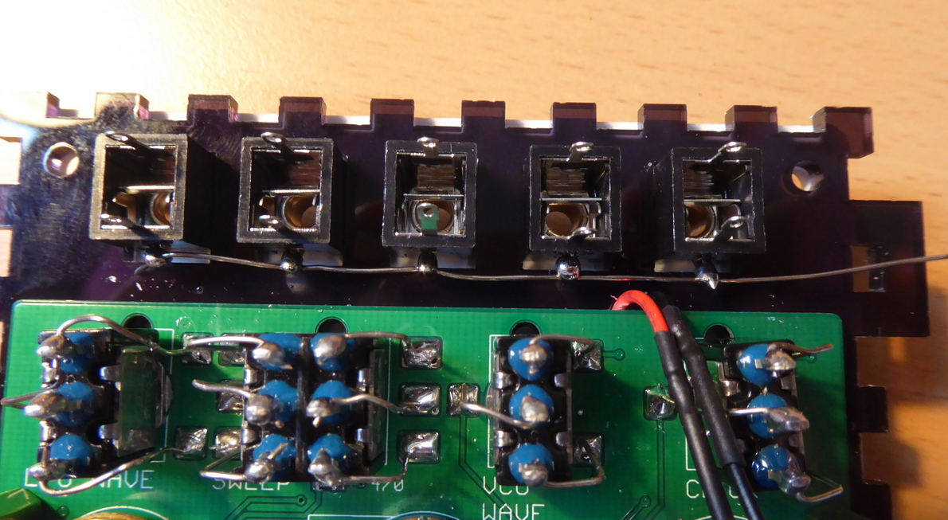

Trim the piezo wires and strip the ends. Connect the black wire to the shield tab of the Input socket and the red wire to the middle pin of the socket as shown

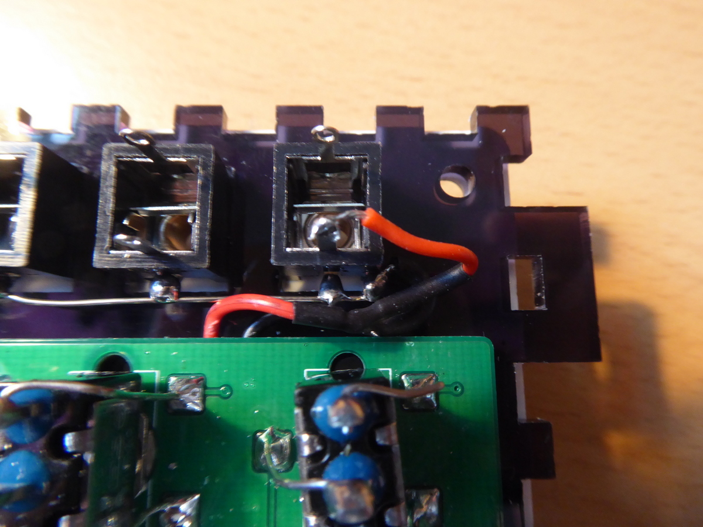

Join the upper pin of the Input socket to the Trig+ pad on the PCB

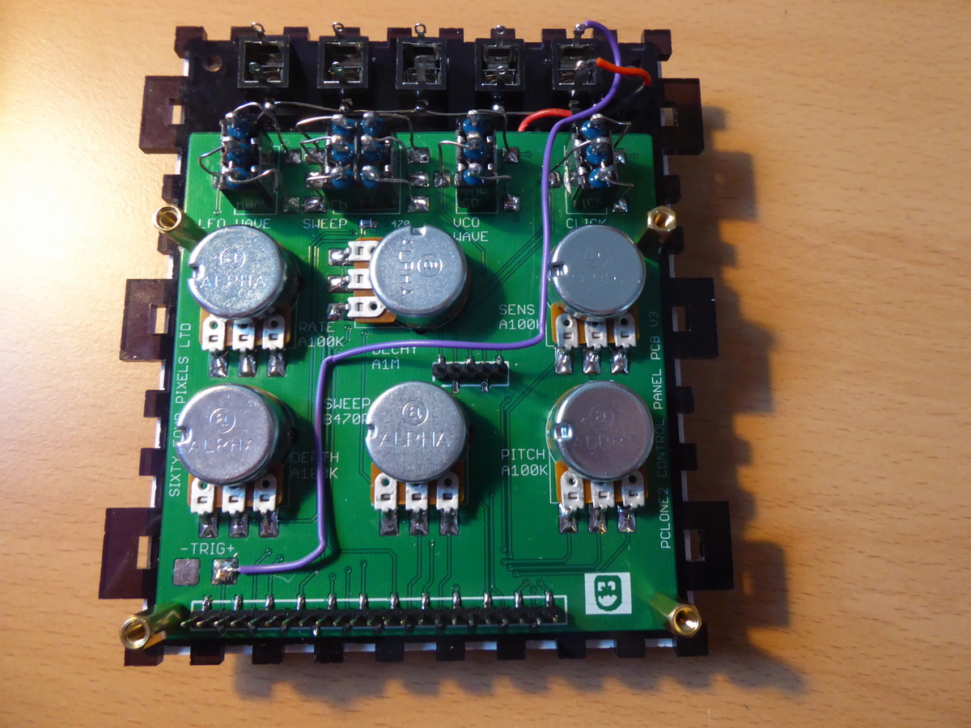

Connect wires to the upper pin and shield tab of the Output socket 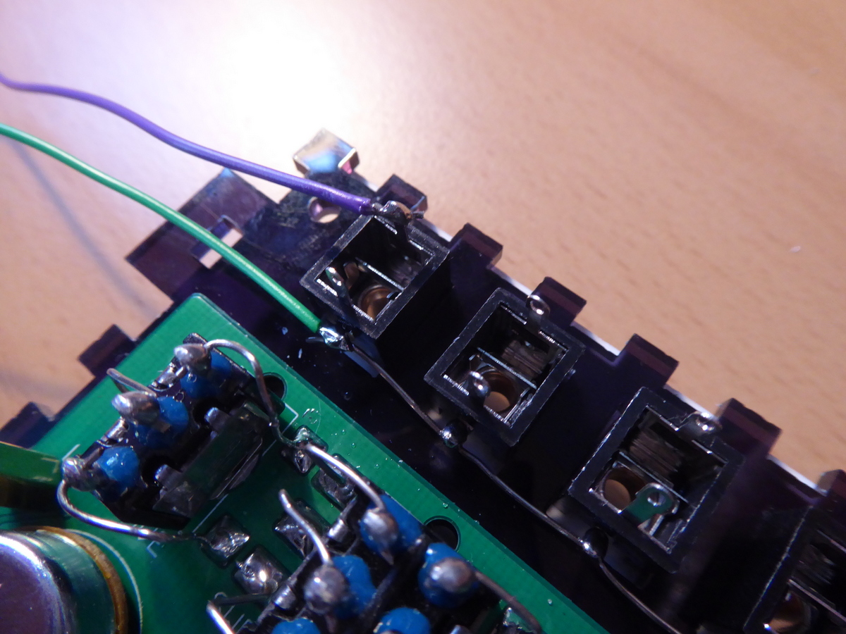

Mount the main PCB on the control panel PCB making sure the headers and sockets line up correctly. Solder the wires from the output socket on to the main PCB output pads

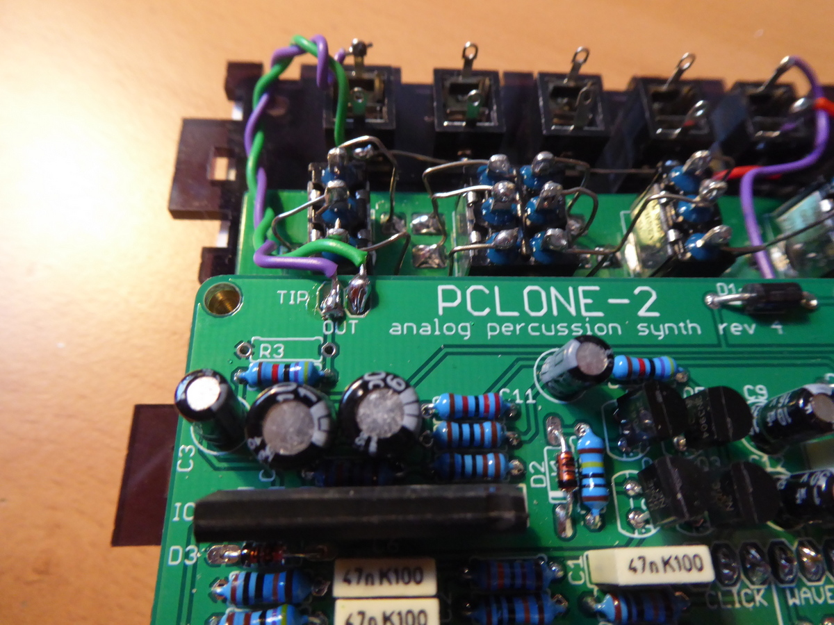

Peel the film from the case end panel (with single hole) and locate the DC power connector

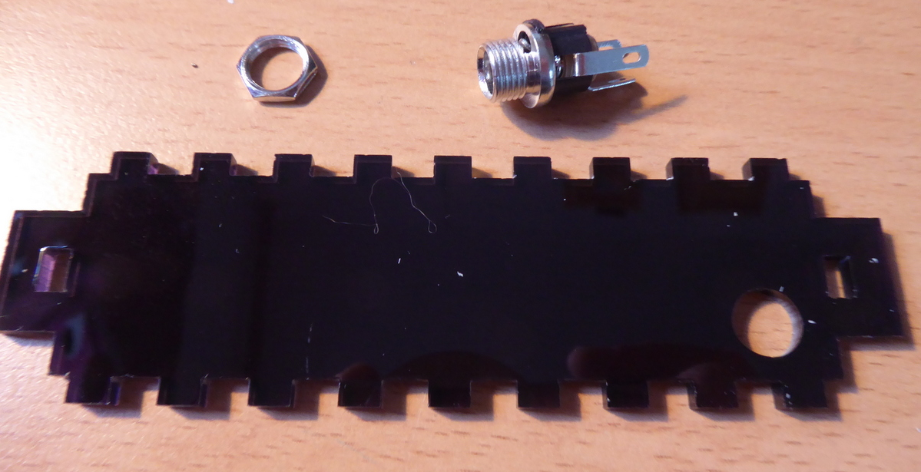

Solder about 10cm lengths of red and black wire to the pins of the socket as shown in the photo below

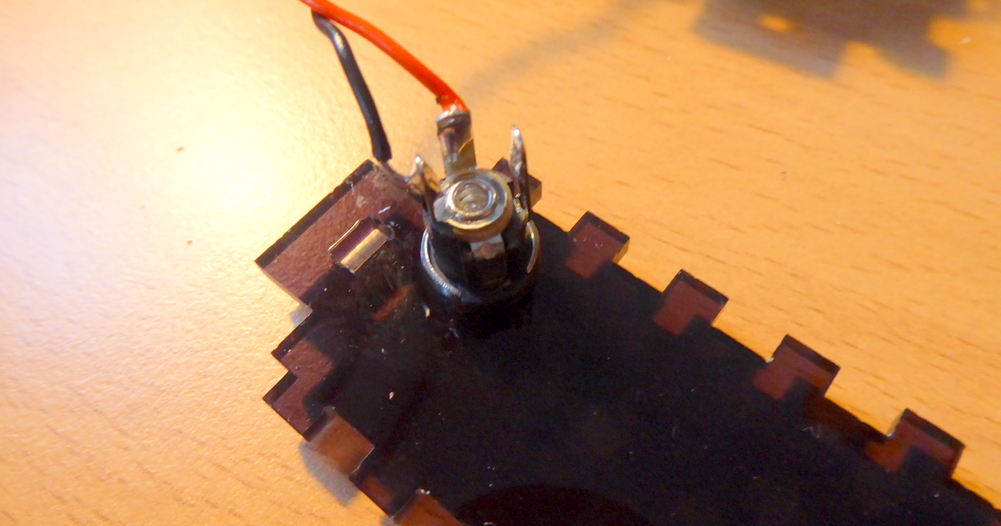

Most guitar pedal style 9V DC adaptors use a negative tip supply and have and the wires should be connected as shown. If you want to use a centre-pin positive supply, solder the wires the other way around.

The rectifier diode on the board protects the circuit from damage by incorrect polarity but the device won’t work with the wrong type of adaptor.

Now is a good time to try it out, before you assemble the enclosure…. move all the control pots to their fully clockwise position and also turn the trim pot R45 fully clockwise. Connect an amp/speaker (start at low volume!) and apply power. Tap the piezo… you should be hearing something…

If all seems good lets finish things off! Locate the four flange nuts and remove the film from the acrylic side panels

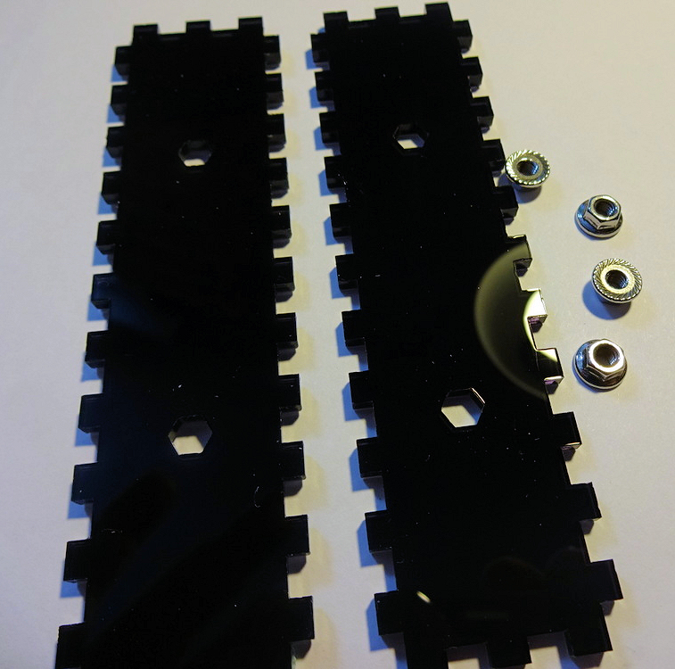

Push the hexagonal parts of the flange nuts into the holes using pressure from your thumb. Do not hammer them or use a vice etc as you will shatter the acrylic!

Note that the laser cut holes for the nuts are very slightly tapered (due to the shape of the laser beam) which means the nuts can be pushed in more easily from one side of the panel than the other. Try to ensure the nuts are inserted from the wider side of the hexagonal holes.

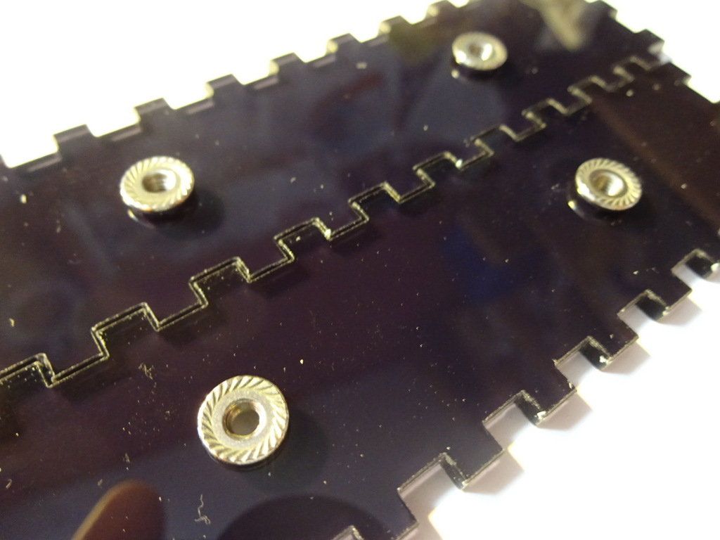

Ensure the film is removed from all the remaining acrylic parts and assemble the sides of the case. Make sure the flange nuts are on the inside! Push on the 5mm acrylic side cheeks which hold everything together.

At this point leave the back of the case off, so we have access to the electronics in case we need to trouble shoot anything. Later, add the back panel by removing the side panels.

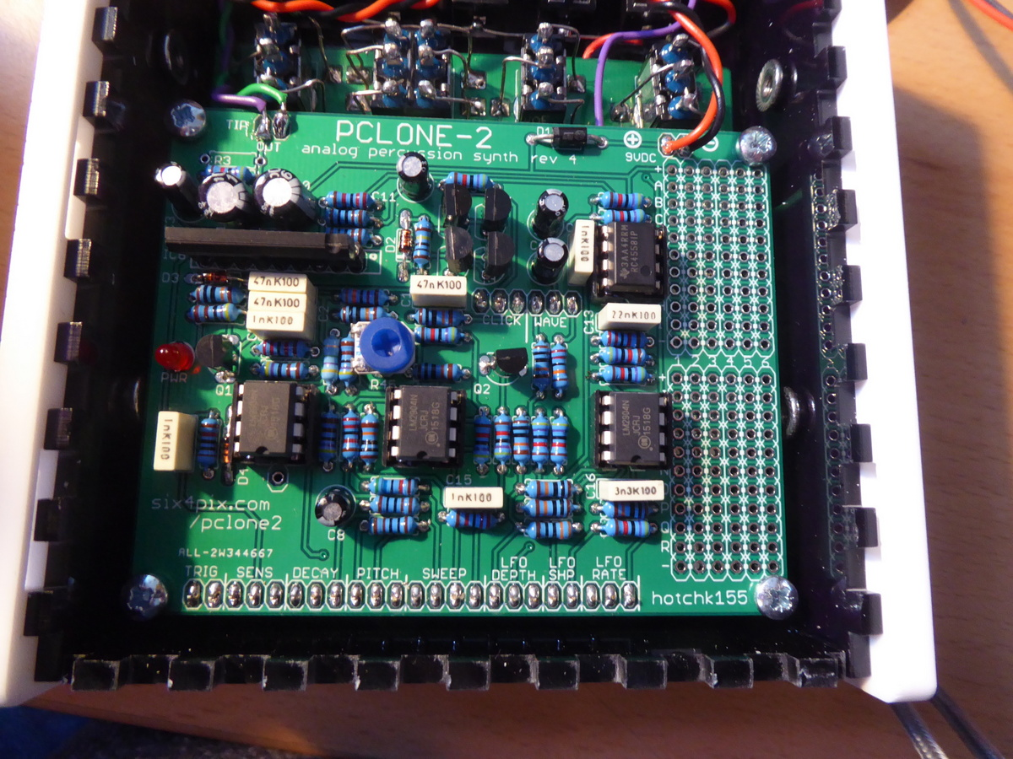

Use the remaining four allen bolts to attach the side panels. Be careful not to over tighten the bolts as this could crack the side panels.

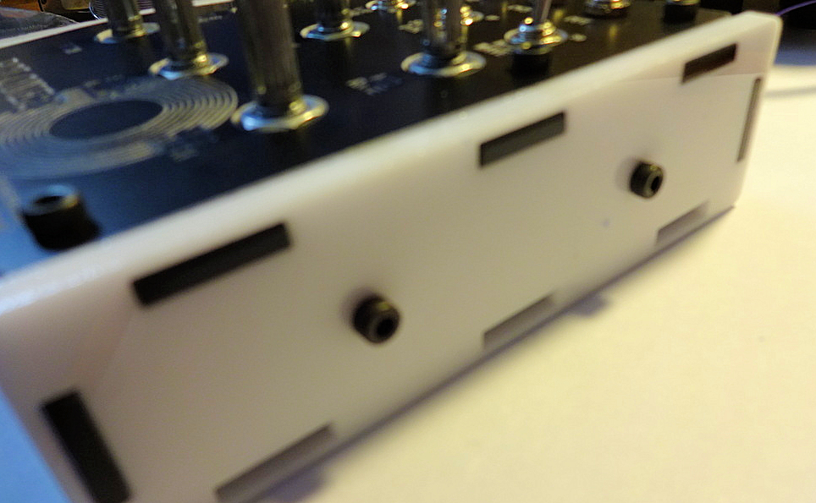

Wind all the pots to their lowest position and attach the knobs (when pots are at minimum the marker on the knob should be at about the 8-o’clock position)

Congrats! you are done. Enjoy the PCLONE2!

